Notes: Cell Membrane Transportation
(Outcome 8)
Biology 11 Name: ___________________
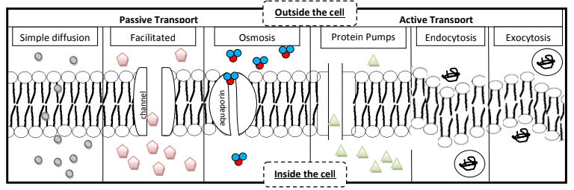
Directions: Using textbook pages 184 to 187 complete the following: 1) use an arrow to show the direction the substances (small molecules, ions, water, larger molecules) are moving across the membrane 2) Highlight or circle yes or no for if the movement uses energy or not 3) Give a summary explaining the form of transportation.

(Molecular Transport)

Uses Energy?
YES or NO | YES or NO | YES or NO | YES or NO | YES or NO | YES or NO
Summary:

