Notes & Practice: Introduction to Photosynthesis
Biology 11 Name:
Directions: Watch the tutorial video provided and fill out the information below as you watch the video. Remember you can pause, rewind and revisit sections of the video as many times as you need to complete the sheet.
Energy
Energy is……
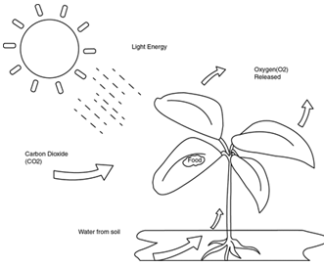
The original energy that fuels all organisms comes from the _________________ in the form of photons and is converted into usable energy (glucose) during the process of ___________________________.
This process converts molecules of __________ and __________ into a larger molecule called glucose.

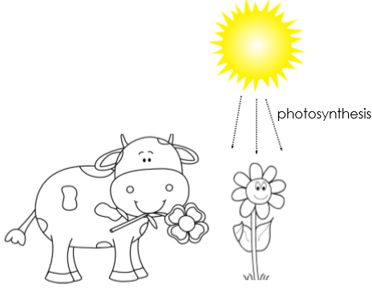
Organisms that make their own food are called ________________________. These organisms are what carry out the process of photosynthesis. Other organisms that rely on others to gain their energy are called __________________________.

Consumer

Producer

_______________________ is a form of energy that is found within living or previously living organisms. The greatest amount of energy within a food chain is found at the ______________________ level. As _____________________________ move energy up the food chain from primary to tertiary energy is lost.

Chloroplast
The disk-like structures within the chloroplast are called ______________. They contain a pigment called _________________________ and are the location for the 1st process in photosynthesis. Stacks of these structures are called ________________.
The area surrounding the disk-like structures is called the _______________. It is where the 2nd process in photosynthesis takes place.
The _______________________ is an organelle within the _______ of plants, algae and photosynthetic bacteria. It is the location where ______________________ takes place.

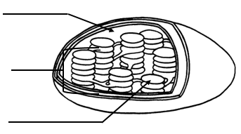

Chlorophyll is a pigment that absorbs packets of energy from the sun called ________________________ to kick-start the process of photosynthesis where _____________ energy is converted into _______________________ energy.

ATP (Adenosine Triphosphate)
During photosynthesis ______________ energy is converted into ________________________ energy in the form of glucose (sugars). Glucose is then broken down into usable energy called _____________ through the process of ____________________ _____________________ in the mitochondria. This process occurs in most organisms.
In animals, glucose is the large molecule of energy consumed in the form of carbohydrates that that is delivered through your blood to reach your cells. Once there it is converted into ATP by the mitochondria.

ATP (Adenosine Triphosphate)
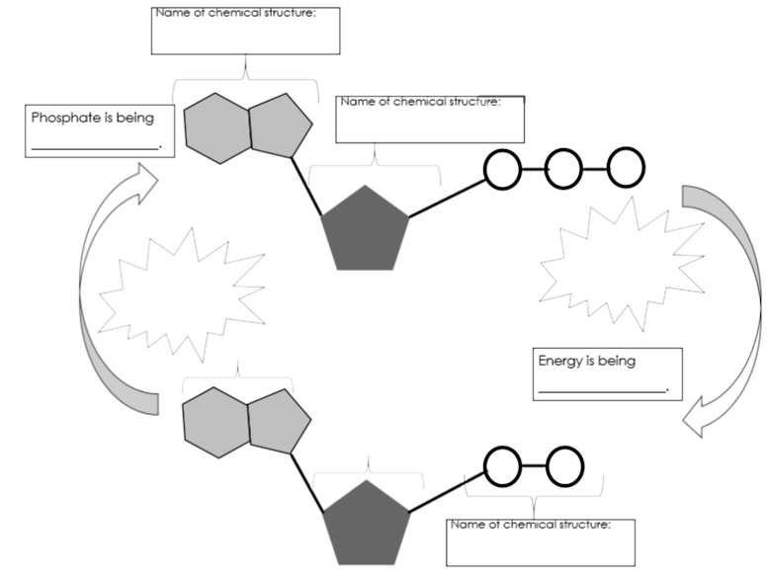
ADP (Adenosine Diphosphate)
Practice Questions:
- The equation for photosynthesis is:
________________ + ___________ + _____________ ______________ + ____________

- Where does the carbon dioxide and water come from?
- What is the overall purpose of photosynthesis?
- Compare the energy storage between molecules of glucose and molecules of ATP.

