Outcome Practice: Classification of Life
Outcomes 11 & 12
Name: Biology 11
Directions: Complete each of the following essential questions using the tutorial as well as the guided notes to help you.

- What is taxonomy? What is the name of the biologist that began taxonomy?

- List the 7 taxa in order from largest to smallest and show an example of this naming system for human beings.

Taxa (order largest to smallest) | Using an organism of your choice, indicate its classification within the 7 taxa.

- Using the diagram below answer the following questions:
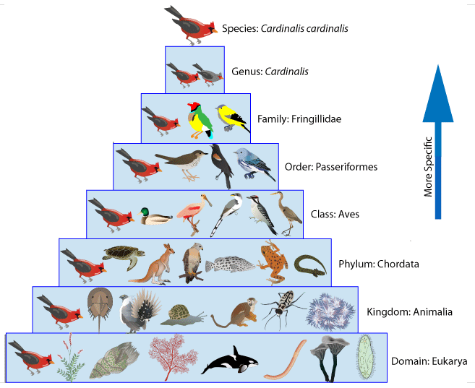
- Is the Cardinal more closely related to the mallard duck or a turtle?

- Explain how you know this according to Linnaeus’s classification system.

- Use the chart below showing 5 species and their hierarchical classification based on Linnaeus’s 7 taxa of classification to answer the questions that follow.
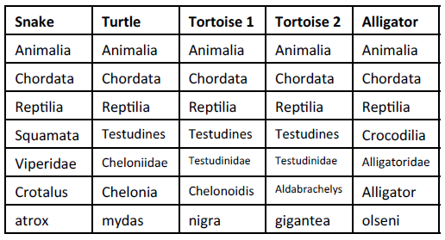
**Note: The chart shows the taxa in order from largest to smallest. **

- What is the scientific naming (binomial nomenclature) of the snake? Remember to think about the naming rules.

- Which of the above organisms belong to the same class?

- Which of the above organisms belong to the same order?

- Which two organisms are most closely related? Justify your answer.

- Which two organisms are most distantly related to one another? Justify your answer

- Which of Linnaeus’s taxa includes the most specific characteristics?

- Which of Linnaeus’s taxa includes the broadest characteristics?

- Which of Linnaeus’s taxa has more species, an order or a family?

- What is binomial nomenclature and who devised it? Give an example.

- What are the 4 rules to binomial nomenclature?

- Explain the difference between classification on Linnaeus’s time and current day classification. How has the method of classifying changed?

