Outcome Practice: Glands & Hormones of the Endocrine System
(Outcome 20)
Biology 12 Name: _____________________________
- What are hormones?

- What is the difference between the body’s response to nerve impulses vs. hormones being released?

- What is the difference between exocrine and endocrine glands?

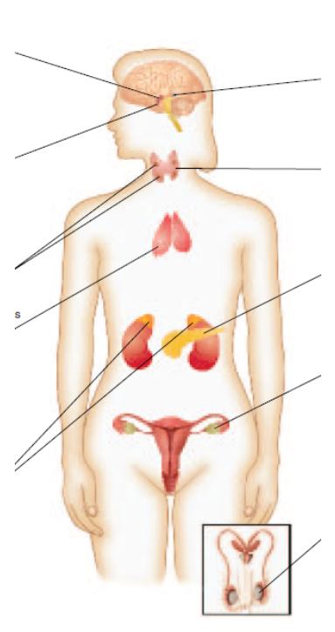
- Label each of the following endocrine glands.

- Create a chart like the one below indicating the hormone each gland produces and what the action of that hormone is.
Gland/Organ | Hormone Produced | Action of Hormone

