Outcome Practice: Incomplete & Codominance
(Outcome 5)
Biology 12 Name: _____________

- Explain the difference between incomplete dominance and codominance.

Incomplete Dominance Questions
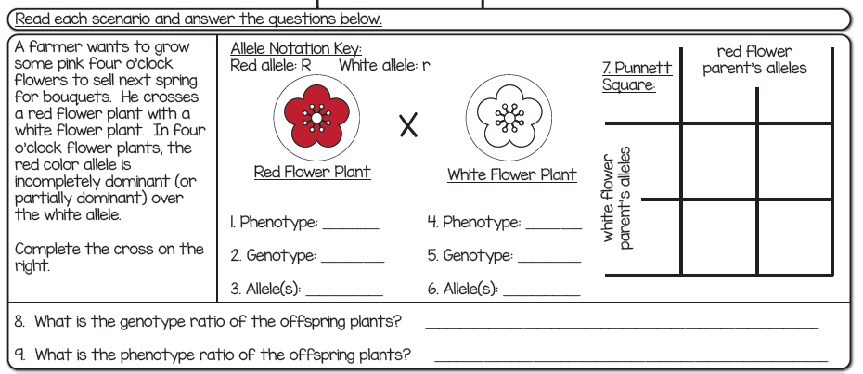

W

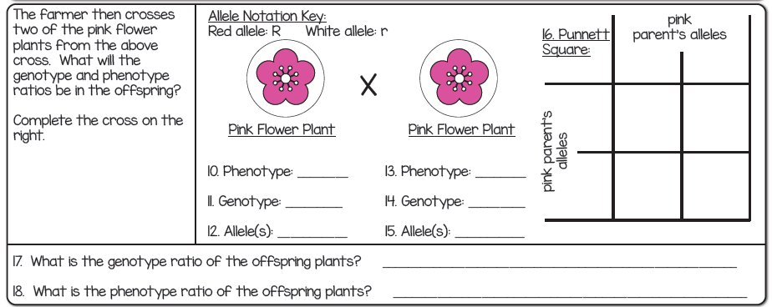
W

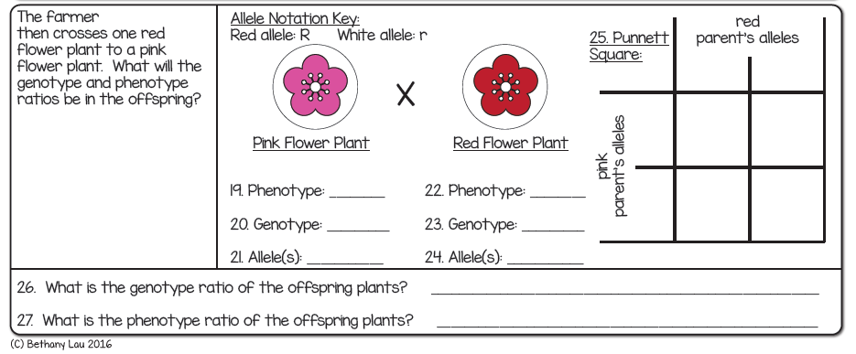
W

Codominance Questions

- In some chickens, the gene for feather colour is controlled by codominance. The allele for black feathers is “B” and white feathers is “W”. The heterogeneous genotype is known as erminette and the phenotype of these chickens is a spotted chicken.

What is the genotype for black chickens? _________

What is the genotype for white chickens? _________

What is the genotype for erminette chickens? _________

- A black chicken and a white chicken are crossed. What is the probability of:

White chickens __________

Black chickens ___________

Erminette chickens ________

- If two erminette chickens are crossed, what is the probability of:

White chickens __________

Black chickens ___________

Erminette chickens ________

