OP: The Neuron
(Outcome 17)
Biology 12 Name: __________________

Directions: Use pages 897 and 898 as well as well as any external resources you may need to use for items you can’t find in the textbook.
- What is a neuron? What is their purpose?

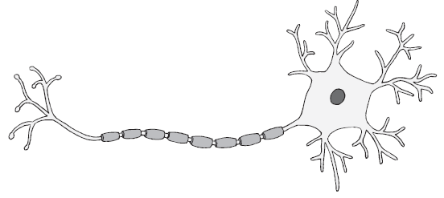
- A) Label the parts of the neuron (see structure names in data table below) using page 897 in the textbook.

B) What is the function of each structure within a neuron? Use the textbook pages 897and 898 in the textbook and/or additional resources if required
Structure Name | Function
Dendrites
Nucleus
Cell body (soma)
Axon
Myelin Sheath
nodes of Ranvier
Axon terminals

