Outcome Practice: Understanding Cladograms
(Outcome 13)

Biology 11 Name: ________________
Directions: Answer the questions below, you may need to do some additional research to be able to complete the questions if you are unaware which organisms contain each characteristic.
- Fill out the following character matrix to assist you in creating a cladogram from the information. To do this, mark an “X” if an organism has the trait mentioned.
 | Multicellular | Jaws | Lungs | Claws/Nails | Fur/Mammary Glands
Hagfish
Perch
Salamander
Lizard
Mouse

- Create a cladogram based on your matrix.

- According to your cladogram, which two species are more closely related: hagfish and salamanders or hagfish and lizards? Justify your answer.

- According to your cladogram, what species are mice most closely related to?

- Add a pigeon to your cladogram based on its characteristics and adding an additional derived characteristic of feathers.
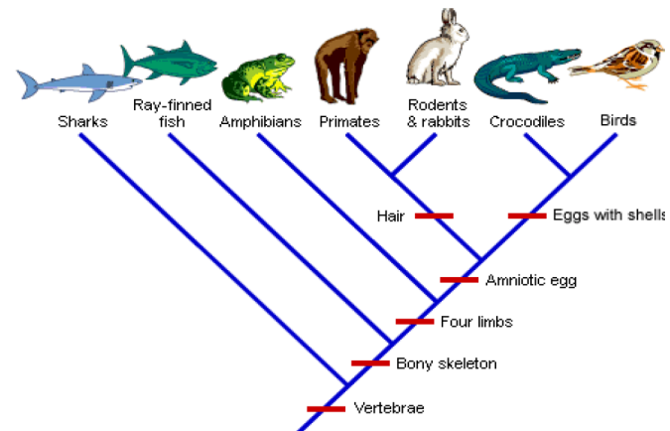

**Use the cladogram to answer questions 6 to 11.

- What trait separates sharks from Ray-finned fish?

- Which organism is most related to the bird? Justify your answer.

- Which 5 traits do the bird and its closest relative share?

- Which organism’s DNA will differ the most from the birds? Justify your answer.

- What separates rabbits/primates from the crocodiles?

- Which organism is most related to the rodents and rabbits?

