Text: Phylogeny & Cladograms
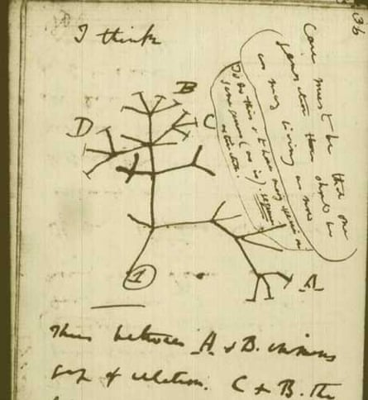
In the 1700’s Linnaeus developed taxonomy with the goal of classifying and name living things. However in 1859 Charles Darwin published the Theory of Evolution opening the way to studying evolution. Darwin also published his sketch of the tree of life showing how species are related through evolutionary history. Throughout the 19th century the Tree of Life began to have fossil findings added to it.

Throughout the late 19th century into the early 20th century paleontologists discovered more and more fossils and began to work to understand the history of animals through the ages by linking their known groups. With this modern evolutionary synthesis so began the modern understanding of evolution and evolutionary taxonomy termed phylogeny. Phylogenetic trees (cladograms) illustrate the relationships among various species according to their DNA and evolutionary relationships.
The diagram below exhibits the evolutionary tree or cladogram of the major groups of plants.
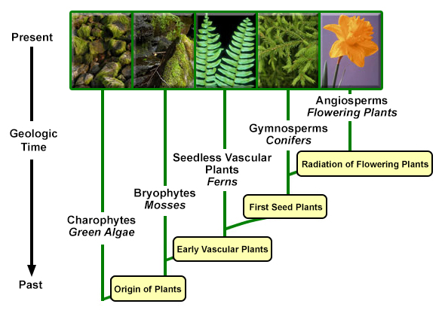
Cladograms all assume the same principles:
- All organisms on a cladogram descend from a common ancestor.
- New organisms develop when existing populations split into two groups.
- Over time, lineages experience changes in characteristics.

