Notes: What are Proteins?
(Introduction to Outcome 7)
Biology 12 Name: _____________
Directions: Watch the video linked on the online classroom or google “What are Proteins – Fuse School”.
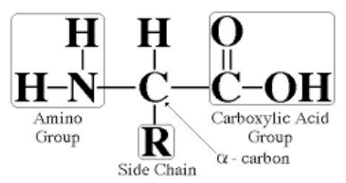
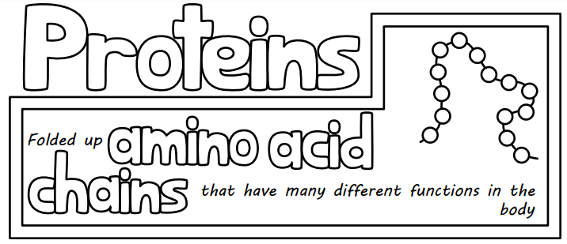Amino Acid Structure
There are ______ different amino acids that all ______________ are made of.
The variation in proteins is caused by the _______________ of amino acids, chain ________________ and by ________________ the chain in distinct ways.

Is specific to each amino acid
- About _________% of your diet should be protein. Some examples of where we find proteins in our diet are:
- The proteins we eat are too _______________ to leave the _________________ intestine and go to the ______________________. Instead _________________ in our digestive system break down proteins into _________________ __________________ which are small enough to move into the bloodstream.
- The amino acids are then built back up into _____________________ where they are used in a variety of ways.

