Outcome Practice: Multiple Alleles
Outcome 5
Name: Biology 12
Multiple Allele Questions
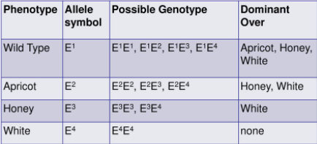
- Using the following chart which indicates the order of dominance for eye colour in fruit flies (that contain multiple alleles) answer the questions below.

- What are the phenotypes of the offspring when a honey eyed (E³E⁴) fruit fly mates with a white eyed fruit fly?

- What would the phenotypes be for the offspring if a homozygous apricot eyed fly were mated with a red (wild type) fruit fly with the genotype E¹E⁴)?

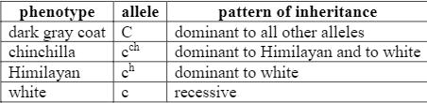
- Coat colour in rabbits is governed by four different alleles. Each allele is responsible for producing a different coat colour: dark grey, Chinchilla, Himalayan and white. Each rabbit has only two alleles. Use the order of dominance table below to assist you in answering the following questions:

- List all the possible genotypes for each coat colour

dark grey rabbit ____________________________________
Chinchilla rabbit ____________________________________
Himalayan rabbit ___________________________________
white rabbit ________________________________________

- Predict the phenotype of a rabbit with the following genotypes.

c^{h}c^{ch} ________________________ and Cc^{h} _______________________________

- Indicate the phenotypes of the F₁ generation from the mating of a heterozygous Himalayan-coat rabbit with a white-coat rabbit.
- Would it be possible to obtain white rabbits if one parent is white and the other is Chinchilla? Explain.

- Would it be possible to obtain Chinchilla rabbits if one parent is Himalayan and the other is white? Explain.

- A Chinchilla rabbit is mated with a Himalayan rabbit. Some of the offspring are white, what are the parents’ genotypes?

Multiple alleles & Co-dominance Questions:

- In smileys, the shape of the eye is controlled by multiple alleles with four possible phenotypes. It is known that the star and dot eyes are co-dominant and the square eyes are a recessive trait. Assign genotypes to each of the smileys pictured (Hint: use superscripts).

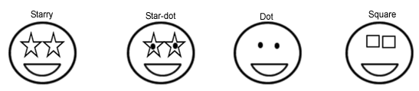

- Show all the possible genotypes for each smiley shown, use F for the allele.

- If a homozygous stary-eyed smiley is crossed with a homozygous dot-eyed smiley what will the phenotypic ratio be for their offspring?

- If a heterozygous stary-eyed smiley is crossed with a heterozygous dot-eyed smiley what will the phenotypic ratio be for their offspring?

- If a starry-dot eyed smiley is crossed with a square eyed smiley what will the phenotypic ratio be for their offspring?
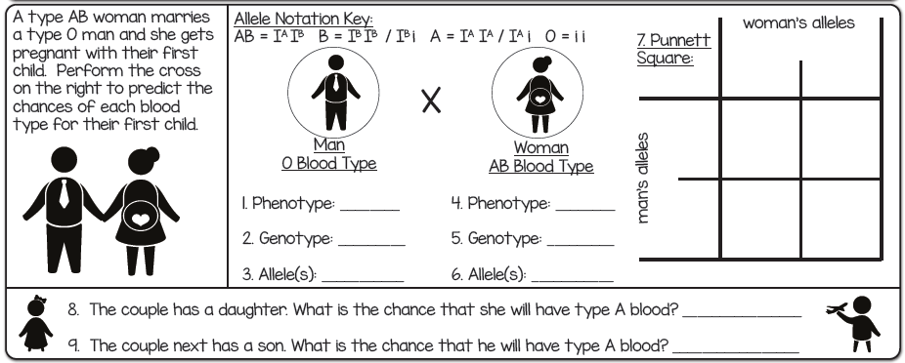

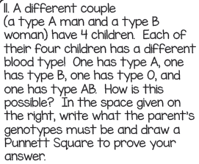
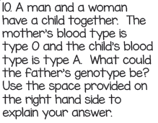
- 6.

