Activity Worksheet: Modeling the Action Potential
Name: Biology 12
Directions: As your group works through the activity directions fill in the questions below when you are asked to. This does not need to be passed in but rather is a way to help you better understand the process of action potential.
- Look at the numbers of brown beans representing the sodium ions in the dishes inside and outside the cell. If the sodium channel were suddenly open so that the sodium ions (beans) could move across the membrane:
  - Which direction would they tend to move based on their concentration gradient: into the cell or out of the cell? Explain.

  - Which direction would they tend to move based on their charge: into the cell or out of the cell? Explain. (Remember, the inside of the cell is negative with respect to outside at rest).

- Look at the numbers of sodium ions on each side of the cell membrane. Compared to the number in each dish at rest, are there (check which is correct):
______ more sodium ions inside the cell now than there were before opening the sodium channels
______ fewer sodium ions inside the cell now than there were before

- Based on your answer to question (b), do you think the internal medium of the cell is (check which is correct):
______ more negative than it was before opening the sodium channels.
______ more positive than it was before
Explain why you answered so.

- Look at the numbers of beans representing the potassium ions in the dishes inside and outside the cell. If the potassium channel were suddenly opened so that potassium ions (beans) could move across the cell membrane:
- Which direction would they tend to move based on their concentration: into the cell or out of the cell? Explain.

- Which direction would they tend to move based on their charge: into the cell or out of the cell? Explain.

- Look at the number of potassium ions on each side of the cell membrane now. Compared to the number in each dish at rest, are there (check which is correct):
________ More potassium ions inside the cell now than there were before opening the potassium channels.
________ Fewer potassium ions inside the cell now than there were before

- Based on your answer to question (e), do you think the internal medium of the cell is (check which is correct):
________ More negative than it was before you had opened the potassium channel (but after you had opened the sodium channel and moved the beans),
________ More positive than it was before you had opened the potassium channel (but after you had opened the sodium channel and moved the beans).
Explain why you answered so.

- If you were to line up a number of models in the classroom to represent a longer stretch of nerve cell axon, what effect would this have on the action potential? Does it make a difference if you start at one end of the long line, or the middle?

- Summarize what happened during each of the following phases using information you learned from the activity:
- Resting membrane =

- Depolarization =

- Repolarization =

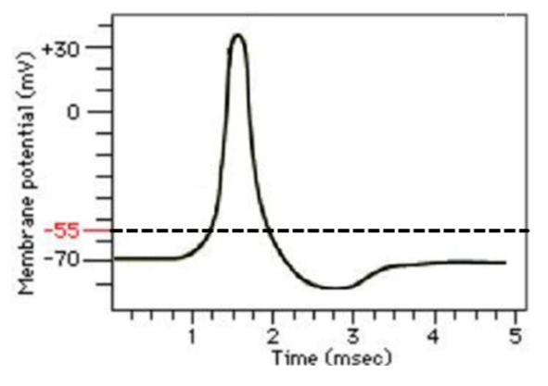
- Using the graph, label where each of the following are occurring on it:
resting membrane
stimulus
depolarization
repolarization
refractory period
threshold level

