Outcome Practice: Cell Membrane & Transportation
Outcomes 7 & 8
Name:
Biology 11
Directions: Answer the questions below to assist you in further understanding cell membranes. You can use the notes we have completed for both outcomes 7 and 8 to assist you in answering the questions.
- What is the purpose of the cell membrane? Why is it referred to as a lipid bilayer?

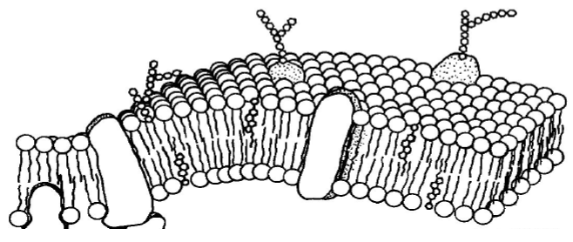
- Label each vocabulary word where it is shown on the diagram.

Vocabulary Words:
inside of cell
outside of cell
protein channel
carbohydrate chain
lipid bilayer

- What is the purpose of the carbohydrate chains?

- Explain why there are protein channels and make sure to include why a protein channel is not always required.

- What does it mean when a membrane is referred to as being semi-permeable?

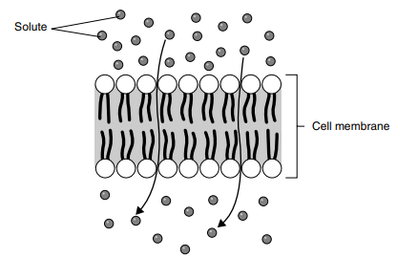
- The molecules of solute in the illustration to the right are moving through the cell membrane from top to bottom. Indicate with labels which side of the membrane has a high concentration of solute and which has a low concentration by moving the text boxes below to the right location (top or bottom) or by labeling the correct location.

- What type of transportation (passive or active) does this diagram represent, explain your answer.
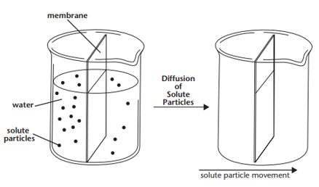

- Look at the beakers on the left and read the description of transportation between the two beakers. Now, in the beakers on the right, draw any changes in water level and show the number of solute particles on each side of the membrane that occur because of the described process.
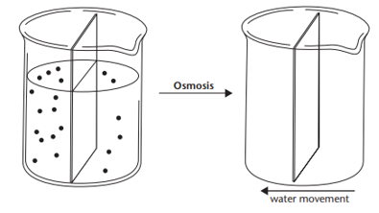
Complete the same as the last beakers….. , in the beakers on the right, draw any changes in water level and show the number of solute particles on each side of the membrane that occur because of the described process.

- Match the situation to the description
Letter | Situation | Description
 | Two solutions are isotonic. | - The solution is above strength in solute.
 | A solution is hypertonic | - The solutions are the same strength.
 | A solution is hypotonic. | - The solution is below strength in solute.

- Identify each diagram as showing an isotonic, a hypotonic or a hypertonic solution inside the cell and describe how the concentration of water molecules will affect the shape of the cell using the textboxes provided. Use page 185 & 186 to assist you.
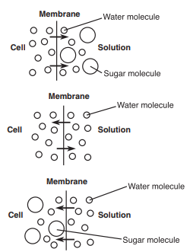

- Complete the table about types of active transport. Use page 189 to assist you.

