Outcome Practice: Polygenic Inheritance
Outcome 5
Name: Biology 12
Polygenic Inheritance Questions:
- As we learned, human height is a polygenic trait which is unlinked and for our sake is determined by 3 genes with the possible alleles of Aa, Bb and Gg with tall being the dominant result and short being the recessive result.

- State the genotype for a person that would be considered a very tall person.

- State the genotype for a person that would be considered a very short person.

- If an individual with the genotype AABbGG has a child with an individual with the genotype AaBbGg what is the likelihood that they will have a child with the genotype AaBbGg?

Here is a thinking cap question!!
- It is believed that there are 8-10 genes that are involved in defining eye colour; however for our purposes we are just going to look at 2 of these genes that determine ye colour. One is called OCA2 and it determines whether the organism’s eyes are brown (B) or not-brown (b) and the other is called Gey which determines whether the organism has green (G) eyes or non-green eyes (g). If an organism has alleles for brown eyes, their eyes will look brown, even if they have any “G” alleles for green eyes. Eyes that have no green or brown look blue.

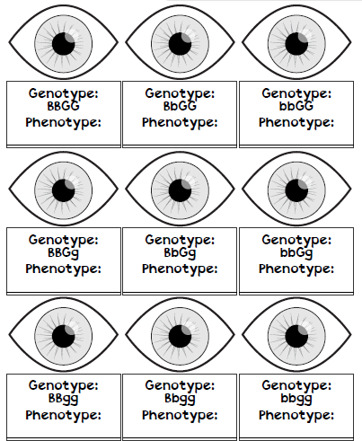
- With the information indicated above, state what the phenotype for each of the genotypes to the right would be:

- Now, using what you know about polygenic problems, calculate either through percentages of each outcome or through a dihybrid cross what the likelihood of a child having blue eyes would be if a woman with brown eyes (BbGg) and a male with green eyes (bbGg) had children.

- What would the likelihood of them having green eyed children be?

- Green eyes are quite rare with only 2% of the human population having them. Why do you think this might be the case?

