Outcome Practice: Dihybrid Crosses
Outcome 4
Name:
Biology 122

Directions: Before completing this sheet make sure you are comfortable in working with monohybrid cross Punnett squares first as this work will build on those skills. Remember the questions on this page are considered essential.
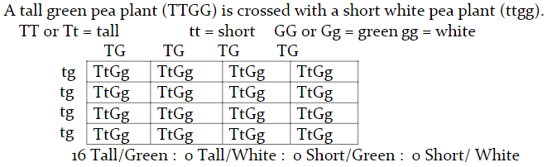
Example:

- A tall green pea plant (TTGg) is crossed with a tall green pea plant (TtGg). Complete the cross below.

What is the phenotypic ratio or fractional breakdown of the plants produced?

- A tall green pea plant (TtGg) is crossed with a short yellow pea plant (ttgg). Complete the cross below.

What is the phenotypic ratio or fractional breakdown of the plants produced?

- Two heterozygous tall, green pea plants are crossed. What are the genotypes of the 2 parent plants in the cross? ______________ X ___________ Complete the cross below using the two parents.

What is the phenotypic ratio or fractional breakdown of the plants produced?

- In horses, the coat colour black is dominant (B) over chestnut (b). The trotting gait is dominant (T) over the pacing gait (t). If a homozygous black pacer is mated to a homozygous chestnut, heterozygous trotter, what will be the ratios for genotype and phenotype of the F₁ generation?

  - What are the alleles for the two traits?
  - What are the genotypes of the parents?
  - Construct a Punnett square showing the cross for the two parents.

  - What is the phenotype ratio or fractional breakdowns of the offspring?

- In donkeys, dark brown fur is dominant to light brown fur and black-tipped tail is dominant to nothing on the tail. Cross a homozygous dark brown, heterozygous black-tailed donkey with a donkey that is heterozygous for both traits. What is the phenotype ratio or fractional breakdowns of the offspring?

