More Practice: Dihybrid Crosses
Outcome 4
Name:
Biology 12

Directions: Complete the questions below to further your understanding of dihybrid crosses. Use the answer board to help you when you get stuck.

Example:
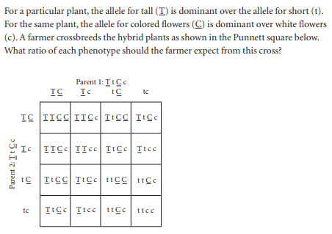

- For a particular rodent, black fur (B) is dominant over brown fur (b), and a long tail (L) is dominant over a short tail (l). Create a Punnett square that shows the genotypes of all the possible offspring that could result from the breeding of two of the rodents that are heterozygous for both traits. List the phelotypic ratio of the offspring.

- A long neck yello giraffe (TtYy), mates with a short neck, orange giraffe (ttyy). Indicate the genotypes of the offspring in a Punnett Square as well list the phenotypic ratio of them.

Possible phenotypes:

Long/Yellow ______: Long/Orange _______: Short/Yellow _______: Short/Orange ______

- Wolves are sometimes observed to have black coats and blue eyes. Assume further that normal coat colour (N) is dominant to black (n) and brown eyes (B) are dominant to blue (b). Suppose the alpha male and alpha female of a pack (these are the dominant individuals who do most of the breeding) are black with blue eyes and normal coloured with brown eyes, respectively. The female is also heterozygous for both traits. Show the possible genotypes in a Punnett Square as well indicate the possible phenotypic ratio.

- Carrion beetles lay their eggs in dead animals and then bury them in the ground until they hatch. Assume that the preference for fresh meat (F) is dominant to the preference for rotted meat and that the tendency to bury the meat shallow (S) is dominant to the tendency to bury the meat deep. Suppose a female carrion beetle, homozygous dominant, for both traits mates with a male homozygous recessive for both traits. Show what the possible genotypes of the F₁ generation would be on a Punnett square? What is the possible phenotypic ratio of the generation?

