Outcome Practice: Identifying Animals
(Outcomes 17 & 18)
Biology 11 Name: ______________________

- Use the notes as well as the outcome practice on the evolution of plants to assist you in identifying which phyla within Kingdom Animalia each specimen below is from.

Specimen | Phyla Identification  (sponges, cnidarians, flatworms, roundworms, segmented worms, mollusks, arthropods, echinoderms, or chordates) | Justification of answer  (explain why you placed the specimen in that group)
Example:  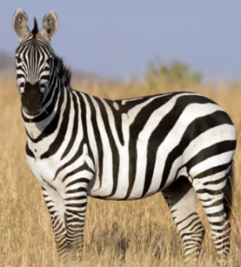  Zebra | Chordata | - Cephalization  - Bilateral symmetry  - Vertebrate  - Has a tail
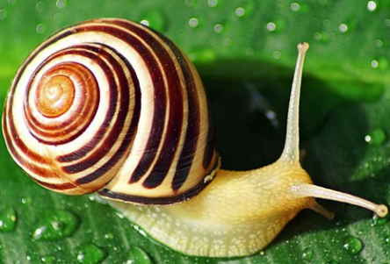
snail
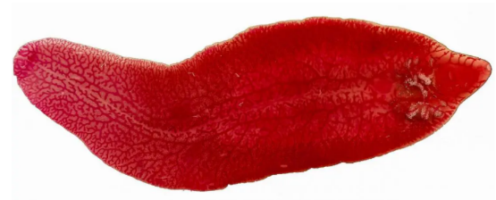
fluke worm
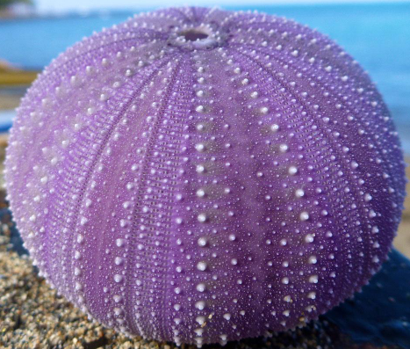
sea urchin
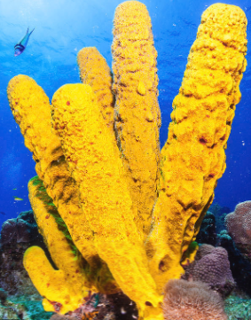
yellow tube sponge
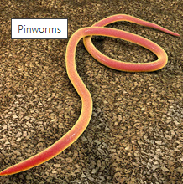
pinworm
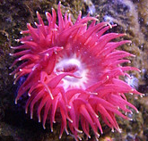
anthozoa
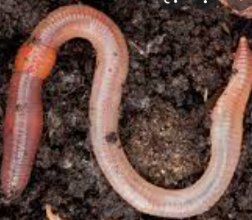
earthworm
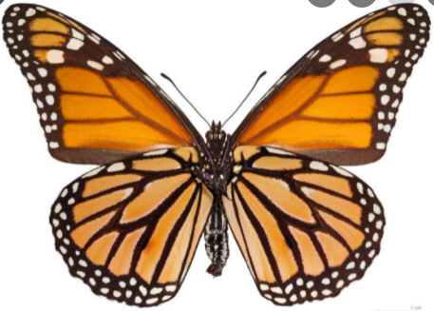
butterfly

