Mission B: Electric Circuits
Mrs. Côté Activity: Understanding Circuits Science 9
Directions: Using the computers provided, go to https://phet.colorado.edu/en/simulation/circuit-construction-kit-dc or type in “circuit construction kit” into google and click on the first option. When you get to the website, click on download and open up the java file that downloads. Follow the step by step procedure below. Make sure to do each step. Fill out the questions asked of you, each of the questions are found within a box.
Purpose: To better understand the relationship between voltage, resistance and current within a circuit.
Procedure:
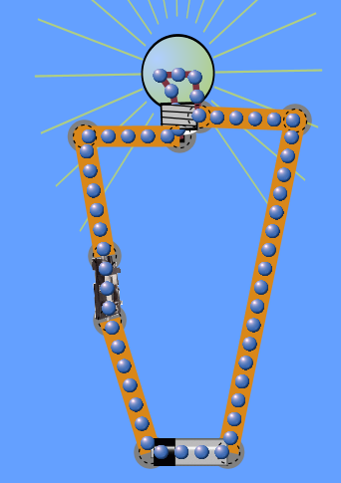
- Build the series circuit shown:
- What do the blue dots represent?

- From which end of the batteries are the blue dots flowing? Is this the (-) or (+) end?

- What happens if the switch is opened? Why does this occur?

- Collect the voltmeter by clicking on the box beside voltmeter to the right of the screen under tools and place the red end on the black part of the battery and the black end on the grey part of the battery.

D. What does a voltmeter measure? What is the standard unit (SI) for this?

E. How many volts are there in the battery? Make sure to include units.

- Look at how you can manipulate the voltage by adding another battery, use the voltmeter to see the volts.
F. Is there a difference in the volts with two batteries? If so, what?

G. Is there any difference in the brightness of the bulb?

H. So …………. the greater the voltage, the _______________________ the light bulb.
brighter or dimmer

- Collect an ammeter by clicking the box beside the ammeter under the tools section to the right of the screen and add it between the battery and light bulb in the circuit.
I. What does an ammeter measure? What is the standard unit (SI) for this>

J. What is the measurement on the ammeter when it is attached to the circuit?

- Remove one of the batteries in the circuit.
K. What happens to the current?

L. So ………… the greater the voltage, the _______________________ the current in the circuit.
less or greater

- Click on the “show values” box under the visual on the right side of the screen to show the resistance in the circuit.
M. What is the total resistance found within the circuit and what is providing the resistance?

- Add a second light bulb to the circuit.
N. What happens to the amount of resistance?

O. What does adding a light bulb do to the current within the circuit.

P. What does the added resistance do to the light bulb?

Q. So ………… the greater the resistance, the ______________________ the current in the circuit.
less or greater

- Add the battery back into the circuit.
R. What happens to the amount of current?

S. What happens to the amount of resistance?

T. What happens to the light bulb?

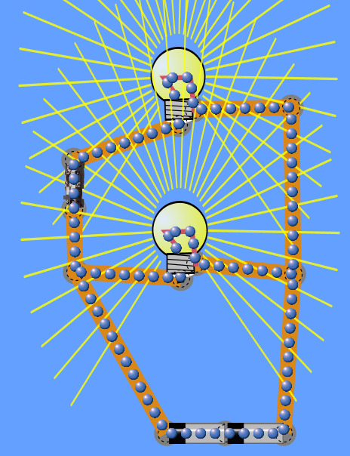
- Create the parallel circuit shown:
- Are the bulbs brighter or dimmer than the ones in the series circuit?

- Why do you think the bulbs are different?

- Hook the ammeter up again.
W. What does the ammeter read?

X. Compare this to the readings done with the ammeter in the series circuit.

Y. What are some things that affect the brightness of the light bulb(s) in a circuit?

