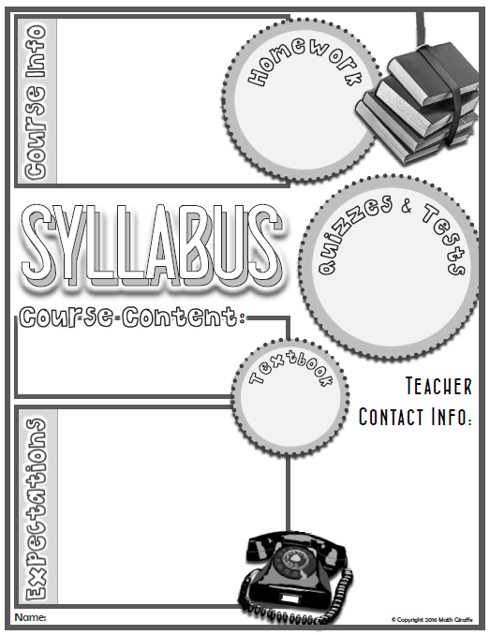

Biology 111/2

**Start of Class:**

About Biology 11:

This course is a one semester course that is intended to introduce students to the biodiversity of living things. Students overall mark will be based on individual assignments, presentations, laboratory work as well as quizzes and tests. It is important that students complete the classwork that is asked of them to assist with their understanding and contribute to their overall practice mark. This course will require a great deal of study and will be beneficial to students looking to further their learning in biology. Biology 11 is an available as a credit for graduation that falls within the science cluster. Attendance will be very important as missed lab and activity work will be difficult to make up.

**Mark Policy:**

* Passing work in on time allows for effective feedback
* Please check your mark routinely to make sure it is up to date (online & in class).
* Late work will be accepted up to the unit end date (will be announced).
* No “extra work” will be given.

**Course Supplies Needed:**

1. Binder
2. lined paper
3. writing utensils

**What can be found on the classroom website?**

<http://mrscoteohs.weebly.com>

* Teacher contact information
* Leave a message for the teacher
* Important OHS links
* Important semester dates
* Classroom procedures
* Course calendar with due dates & test dates
* Unit assignments
* Quiz & test information
* Mark request form

**Classroom Expectations**

1. **Arrive on time and prepared for class.**
2. **Respect the individuals and property within the room.**
3. **Be responsible for your marks and the work you complete.**
4. **Work to the best of your ability**

* W @ 12:10 to 12:40 or by appointment
* T, TH & F @ noon door is open for independent work

**Classroom Website:**

* Notes
* Electronic InBox
* Class Due Date Calendar
* Class information
* Assignments

**What can be found on the classroom website?**

<http://mrscoteohs.weebly.com>

* Teacher contact information
* Leave a message for the teacher
* Important OHS links
* Important semester dates
* Classroom procedures
* Course calendar with due dates & test dates
* Unit assignments
* Quiz & test information
* Mark request form