Extension Questions: Modern Classification
Mrs. Côté Biology 11
Directions: Read the introduction below and refer to the Internet if needed for more research to answer the following extension questions. Remember these are extension so will not necessarily be 100% taught in class so if additional help is needed attend a DSB for more help.
Introduction
Linnaeus’s idea of classifying organisms according to biologically important characteristics has its limitations and problems. See figure 18-6 on page 451 to see these problems in action. By classifying species in the picture based on observable traits we would group barnacles and limpets together; however today crabs and barnacles are grouped together as crustaceans and a limpet is identified as a mollusk. This idea of not just looking at the physical characteristics comes from Darwin’s work looking at evolutionary relationships between species called evolutionary classification or Phylogeny. This method uses cladistics analysis where only the characteristics of an organism that are evolutionary based (new characteristics that arise as evolutionary changes happen over time) and are shown through a cladogram.
To help better understand phylogeny, watch the video below and complete the activity on how to make a cladogram. These are both able to be found on the classroom website.
Evolutionary Classification & Cladograms
- Create a cladogram (on backside of sheet) of the minions using the information below.
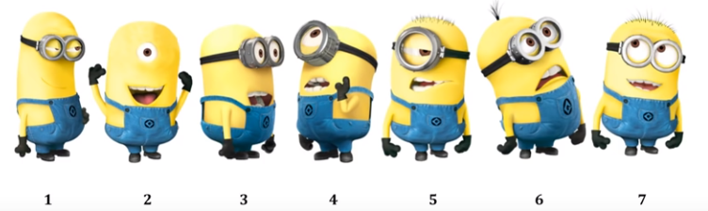

 | Has goggles | Has hair | Has 2 eyes | Pointed teeth | Sprout hair | Long body
Minion 1
Minion 2
Minion 3
Minion 4
Minion 5
Minion 6
Minion 7

Classification using DNA and RNA
- Scientists have turned their understanding of classification to similarities in DNA and RNA, explain how this process is used and give examples of where similar genes in humans and yeast have been found.

- You are a biologist who is searching for new species in the Amazon jungle. You find two new species of beetles, beetle A and beetle B that resemble each other closely but have somewhat different markings on their wings. In addition, both beetle A and beetle B resemble a species of beetle, beetle C that has already been identified.

- How could you use DNA similarities and differences to determine whether beetle A and beetle B are more closely related to each other than to beetle C?
- Explain how using genes of organisms is important to understanding classification and evolutionary relationships.
**Use page 454 to assist you in answering**

- What is molecular clock? How are we able to show how long ago two species shared a common ancestor? Use page 455 to help you answer.

Mutations causing Evolutionary Change in DNA

- What is a gene mutation (point mutation)?

- Explain what occurs with each type of mutation: a. substitution b. insertion c. deletion

- What are the possible consequences to a mutation?

