Extension: Protein Synthesis
Name: Biology 12
- What are transcription factors and what is their purpose? You will need to research this.

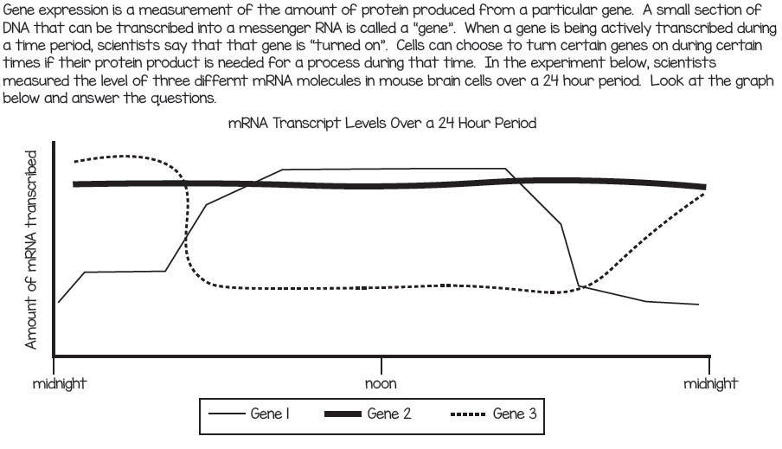
- Now that we understand that certain genes are “turned on and off” in different cells around the body we can now look at how this happens in research done on brains of mice over 24 hours.

- Which gene could be involved in promoting sleep? _____________________________

- Which gene could be activated by exposure to sunlight? _________________________

- Which gene encodes a protein that is most likely necessary at high levels in the cell at all times? __________________________________

- What are nucleases and how are they used in the cell to control how much of a particular protein is present in the cell? Use the internet to look up your answer.

- What is the proteosome and how is it used in the cell to control how much of a particular protein product is present in the cell? Use the internet to look up your answer.

- We discussed introns when looking at transcription, remember they are the sections that are cut out during the period of time that mRNA is modified before leaving the nucleus. For a long time it was believed that introns were “junk DNA” and when they were removed they were broken down by enzymes and their materials were reused. Newer research is showing that this might not be 100% the case, look at this website and the video that is found on it to learn more about our understanding of introns today. What do we believe the possible role(s) are for introns today?

- Although mRNA vaccines were being studied and developed over the last 20 years, it was the current Covid-19 pandemic that has brought these vaccines to fruition. Watch the video linked HERE and answer the questions below.
- What is the make-up of the original vaccines, for example the vaccine for influenza, the MMR vaccine you receive at a very young age?

- The current Covid-19 vaccines are made of mRNA and DNA. Explain how this these have shown to be beneficial.

- Explain how does a mRNA vaccine work (this has a lot to do with protein synthesis)?

