Kingdoms Extension Questions
Name:
- What used to be the name of the kingdom that contained both of the prokaryotic kingdoms within it? (research on own)

- Explain why Kingdom Protist being sorted based on mode of nutrition is different than the sorting done for the other kingdoms? (pg. 498)

- Research a cladogram that would show the evolutionary path of Protists. What exemptions do many organisms along the way have? (other resource than textbook)

- Using the diagram on page 528, sketch the structure of a typical fungi making sure to label the hyphae, fruiting body and mycelium and indicate what the function of each is.

- Kingdom Fungi is broken into classifications based on the means of reproduction. State how each of the 4 classifications reproduce. (pg. 530, 532, 534 & 536)

- Explain what is meant by “fungi are essential to maintaining equilibrium in an ecosystem but can also be the reason for its disruption”. (pg. 538)

- Define each of the following terms:
- gametophyte

- sporophyte

- spore

- gametes

e) zygote
- Use the textbook on page 552 which discusses the life cycle of plants (alteration of generation) and answer the following questions:
- Using the diagram below and page 552 in the textbook label where the following vocabulary words would go: pollen, zygote, gametophyte, sporophyte

- Give a brief description of what occurs during alteration of generation
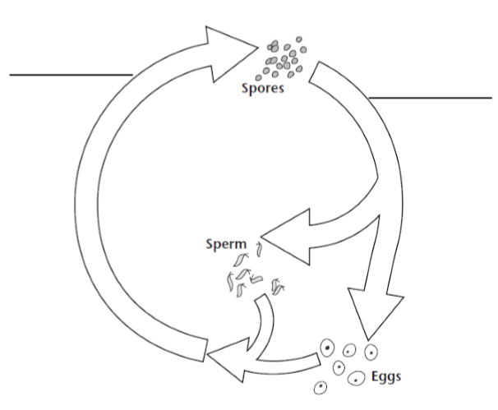

- Identify what parts of the cycle are considered haploid (N) and what parts are considered diploid (2N).

- Explain why this cycle is called “Alteration of Generation”.

- Explain what a seed is making sure to include the following in your explanation: embryo, seed coat and stored food supply. Create a diagram showing each as well.

- Explain why Coniferophyta are considered “naked seeds” and Anthophyta are considered “protected seeds”.

- Within angiosperms there are two classes (monocots and dicots) explain the difference(s) between them.

