Circulatory System: Blood Pressure – Guided Notes
(Outcome 21 & 27)
Blood Pressure
- – the pressure of blood in the circulatory system
- when the heart is and when the heart is
- Sphygmomanometer is used to measure blood pressure
- Typical blood pressure is 120/80 mmHg

Question: What do the numbers 120/80 mmHg actually mean?

Systolic vs Diastolic

Systolic Blood Pressure
- the force felt when arteries
- number on blood pressure reading

Diastolic Blood Pressure
- force felt when arteries
- number on blood pressure reading

Valves of the Heart
- valves prevent of blood
- "lub dub”

- Pulmonary Valve
- Tricuspid Valve
- Aortic Valve
- Mitral Valve

Do you remember? why do valves only exist in veins and not arteries?

How is blood pressure controlled?

1. Sensory receptors
- Detect levels of blood pressure, sending impulses to the medulla oblongata region of the brain stem
- If pressure is , the autonomic system releases neurotransmitters causing smooth muscles in blood vessels to
- If pressure is neurotransmitters are released that elevate blood pressure by causing smooth muscles to

Extension: what part in the feedback loop would the medulla oblongata be for blood pressure?

2. Kidneys
- Regulate blood pressure by removing water from the blood as directed by hormones released by the heart and other organs
- If blood pressure is , kidneys remove water from the blood reducing the blood volume
blood pressure
- If blood pressure is a hormone is released to stimulate the retention of sodium and water, increasing the blood volume
blood pressure

Extension: How does this relate to homeostasis?

BP & Homeostasis
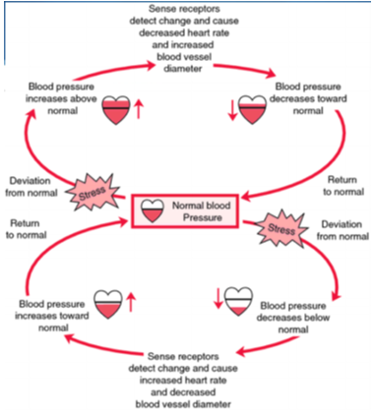

Hypertension
- High blood pressure is considered 140/90 mmHg or higher
- Can weaken or damage heart muscles and blood vessels
- People with high blood pressure are more susceptible to coronary heart disease and have an increased risk of heart attack and stroke

Prevention
- regular exercise
- balanced diet
- no smoking

