Breathing & The Diaphragm
(Outcome 22)
Name: Date:

What is Breathing?
- Breathing and respiration are related, but they are not the same
  - – the release of energy by combining oxygen with digested food (glucose)
  - – taking air into the lungs and forcing the air out of the lungs
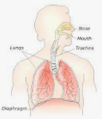
- The are the organs involved with breathing
main organ of the respiratory system
- Breathing happens by the actions of the lungs

The Diaphragm
- Your chest size changes when you breathe because of the:
  - Actions of your muscles
  - Actions of your muscle
- – a large flat muscle at the base of the lungs that aids in breathing

Fun fact: does anyone know what your rib muscles are called?

Feedback Loop of Breathing
- The amount of carbon dioxide in your blood INCREASES to a certain level . . .
- The INCREASE is sensed by a receptor in your body . . .
- A message is sent to your brain . . .
- Your brain sends a message to your diaphragm and rib muscles to INCREASE the size of your chest cavity . . .
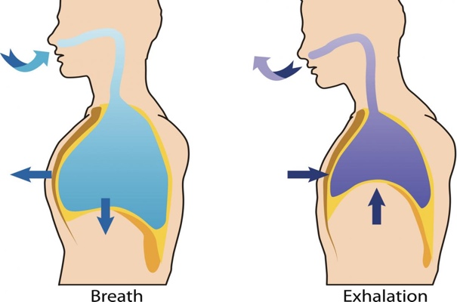
- This causes more air to move into the lungs, DECREASING the amount of carbon dioxide in your blood

Task: Identify the parts of this feedback loop. above

Mechanics of Breathing
- It is the moving of your that makes your lungs and
- Breathing IN
  - Chest cavity moves
  - Diaphragm moves
- Breathing OUT
  - Chest cavity moves
  - Diaphragm moves

Boyle’s Law - INHALE
Breathing IN
- Chest cavity moves
  - Diaphragm moves
    - INCREASES volume of chest cavity
      - DECREASES pressure in the chest cavity
        - Allows air to rush the lungs

Boyle’s Law - Exhale
Breathing OUT
- Chest cavity moves
  - Diaphragm moves
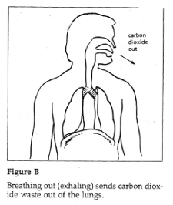
    - DECREASES volume of chest cavity
      - INCREASES pressure in the chest cavity
        - Air is forced the lungs

Extension: why does pressure INCREASE when volume DECREASES?

