Guided Notes – The Digestive System
(Outcome 24 & 25)
Name: Date:
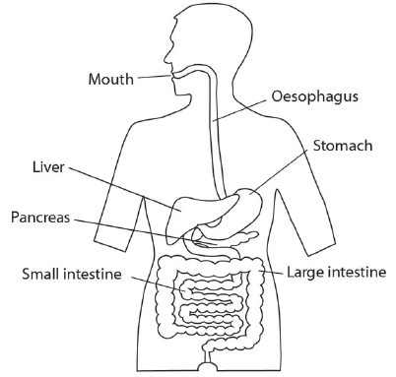
Purpose & Function
- Function to help convert foods into simpler molecules that can be and by cells in the body
- Your body cells convert the chemical energy stored in food into ATP
- Includes mouth, esophagus, stomach, small intestine, and large intestine.

Energy in Food
- Energy in food can be measured by burning it
- – the amount of heat required to raise 1g of water by 1*C
- Fat 9 calories per gram
- Carbs & Proteins 4 calories per gram
- Food supplies the raw materials used to and the body
  - make proteins that regulate cellular reactions
  - make phospholipids in cell membrane
  - make the DNA in your genetic material

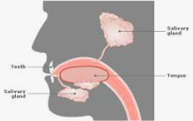
Mouth
- Purpose large food particles into smaller ones
- cut, tear and crush food
  - anchored in bones of the jaw
  - surface protected by mineralized enamel
- breaks down and moistens food for easier chewing
  - contains enzymes called amylase
  - amylase – breaks down carbs and starches into sugars

Esophagus & Stomach

Esophagus
- Purpose to push (chewed up ball of food) down the throat
- Food is moved along by contractions of smooth muscle –
- Sphincter closes the esophagus after food has passed into the stomach prevents contents of stomach from moving back up the esophagus

Stomach
- Purpose a large where digestion is continued
- Exits stomach through the pyloric sphincter

Small Intestine

1. Duodenum
- Purpose and of the food you eat
- Lined with tiny finger-like projections to increase surface area
- Almost all the digestive enzymes enters the small intestine
  - Amylase break down starch
  - Trypsin break down protein
  - Lipase break down fat
  - Maltase, sucrase and lactase break down carbohydrates further
  - Peptidase break down protein further
- Digestive fluid comes from the pancreas, liver, and lining of
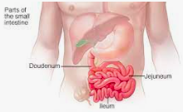
2. Jejunum & Ileum
- Purpose of nutrients
- Approx. 6m long
- Most digestion is complete at this point
- Most of digested proteins and carbs are absorbed into the capillaries ( )
- Molecules of undigested fat and some fatty acids are absorbed by lymph vessels
- There is very little enzymatic activity in your small intestine

Pancreas
- Behind the stomach
- 3 important functions
- Produce regulate blood sugar levels (insulin)
- Produces break down CHO, proteins, lipids and nucleic acids
- Produced neutralizes stomach acids

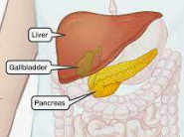
Liver
- Just above and to the right of the stomach
- Purpose produces
- – a dissolving detergent that helps dissolve fat in fatty foods
  - Stored in a small pouch like organ called a
  - Does not contain enzymes
  - Breaks up large droplets of fat into smaller droplets

Large Intestine (Colon)
- Purpose to from undigested food
- across the wall of the large intestine
- Bacteria present in the large intestine produce compounds that the body can use (ex. vitamin K)
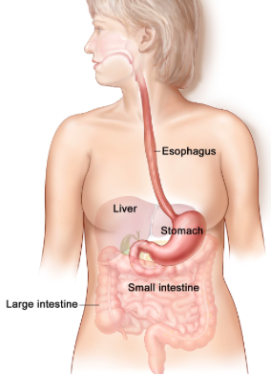
Extension: What would happen to these bacteria if you took large amounts of antibiotics?

