Guided Notes: Homeostasis (Outcome 21)
Biology 12 Name: ______________________

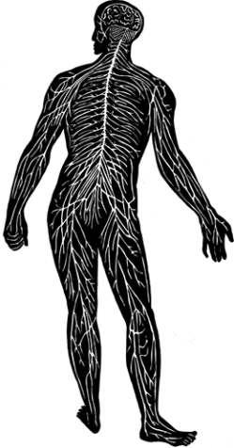
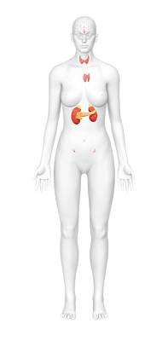
The endocrine system _________________ hormones that _______________________ all biological _____________________.
The nervous system _________________ and __________________ the body by communicating ___________________.

Together these _________________________ regulate _______________________________.

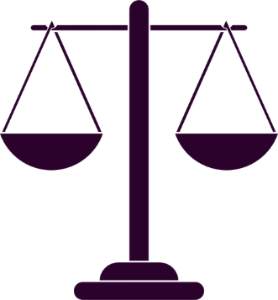
Homeostasis
- ______________________________ = when the organ systems of the body work together to ________________________ a relatively _________________________, stable __________________ environment despite the _____________________________ and ____________________________ conditions.
- If this cannot occur the _____________, ___________________ and body systems can start to ________________________ down.

- Homeostasis is regulated through _________________________ loops. Most are _______________________ loops but some can be ________________________ loops.
- ______________________ loops _____________________ the effect.
- _____________________ loops turns _________________ at a __________-____________________.

Negative Feedback Loop: Hormone Regulation
Stimulus | Produces ___________________ in variable.
Receptor | Detects the ______________________ change (_____________________).
Control Centre | The _____________________ gland releases its own ____________________ or a _____________________ hormone for another __________________ to respond to the receptor.
Effector | ____________________ to the ____________________ of the control centre.
Response | ___________________________ or ________________________ the stimulus.
Homeostasis | The ______________________ becomes in __________________ and turns off the feedback loop.
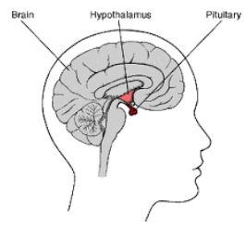
_______________ gland releases its own _____________________ or a ________________________ hormone for another __________________ to do so.
_____________________ detects variable ___________________ and sends a ______________________ in the form of a ______________________ hormone.

Inhibition

Example: Thyroxine

