Circulatory System – Guided Notes
(Outcome 21)
Name: Date:

Function of the Circulatory System
- Function: the circulatory system transports , , and around our body

How does it do this?
- is the muscle that pumps blood around the body
- are the tubes that carry blood throughout the body
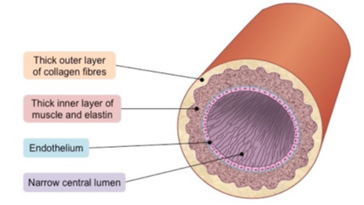
- is the combination of liquid and specialized cells that carry gasses, nutrients, and waste throughout the body

Blood Vessels

Arteries
- – carry blood from the heart
- Strong, thick tubes with smooth and connective muscles to keep blood moving
- valves

Extension: why is it essential that arteries are thick and strong?

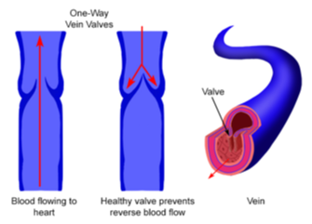
Veins
- – tubes with valves that bring blood the heart
- Walls of veins (like arteries) contain connective and smooth muscles push blood through veins
- valves one-way only

Extension: why do veins have valves but arteries do not?

Valves of the Heart
- valves act to keep blood moving in the correct direction
- prevent of blood
- "lub dub"
  - lub - the first sound which is the sound of the mitral and tricuspid valves closing
  - dub - the second sound which is the sound of the aortic and pulmonary valves closing

Extension: why do valves only exist in veins and not arteries?

4 Valves in the Heart
- prevents backflow of blood from the pulmonary artery to right ventricle
- prevents backflow of blood from right atrium to right ventricle
- prevents backflow of blood from left ventricle to aorta
- prevents backflow of blood from left atrium to left ventricle

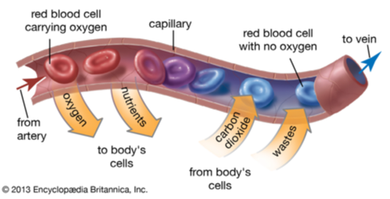
Capillaries
- – deliver oxygen and nutrients to the cells
- Tiny, thin-walled tubes
- Absorb waste (urea) and carbon dioxide
- Transport wastes from the cells

Extension: why do capillary walls need to be small and thin?

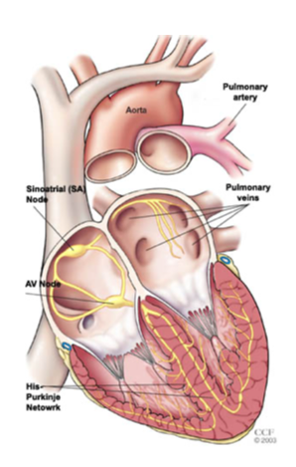
Arteries Capillaries Veins
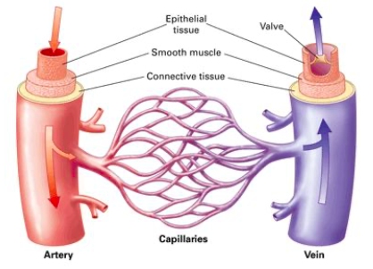

The Heart
- Approximately the size of a clenched fist
- Beats an average of 72 times per minute
- Protected by a sac of tissue called the
- Two layers of epithelial and connective tissue that are on either side of a layer of muscle called the
- separates right and left side of the heart
- – circulates blood from the heart
- - oxygen rich blood pumped from the heart

Heartbeat
- Contractions begin in a small group of cardiac muscle fibres called the sinoatrial node
SA Node = pacemaker of the heart
- Impulse spreads from SA node to the atria
- Impulse picked up by atrioventricular node ( )
- Impulse is carried to a network of fibres in the ventricles
- Rate of heartbeat (heart rate) depends on the body's need for oxygen
- Need more oxygen heart beats
- Do not need more oxygen (homeostasis) heart beats

Extension: do both the atrium and ventricles contract at once? why or why not?

Extension: what effect would exercise have on your heart rate?

