Guided Notes: Neural Circuits
(Outcome 19)
Biology 12 Name: ______________________

What is a Neural Circuit?
______________________ are linked together in _________________ that _________________ travel through sending _________________________ from neuron to ____________________ across ____________________ between them.

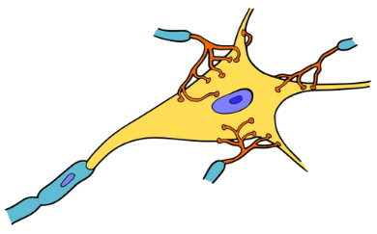

Using the neuron, indicate the direction of an impulse along it.
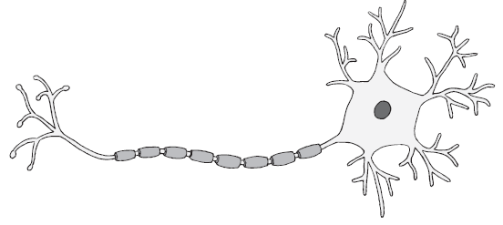

A _____________________ takes information from the __________________ or ________________________ environment, carries it to the ________________ or ________________ cord which then sends it to an area of ________________.

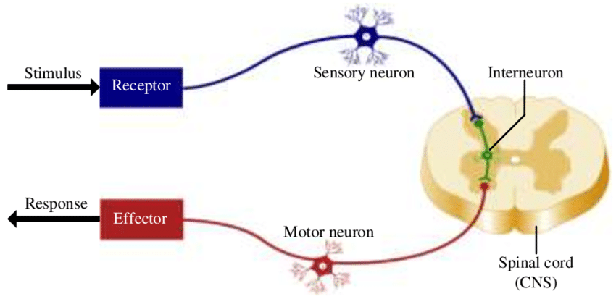
Example of a neural circuit:

What is a Reflex Arc?
- A neurological ____________________________ that controls a _________________. Examples:
- They are an _________________________, ________________________ response to a __________________ and are the ___________________ or neural circuits.
- They are seen as a possible ________________________ response.
- Order of a circuit:

Example of a neural circuit diagram: Stepping on a Tac
