The Respiratory System: Parts & Purpose
(Outcome 22)
Name: Date:

What is the Respiratory System?
- – the release of energy by combining oxygen with digested food (glucose)
Glucose (fuel) + oxygen energy + water (waste) + carbon dioxide (waste)
- Purpose allows gas exchange of and between the blood, air and tissue
- consists of the nose, mouth, pharynx, larynx, trachea, bronchi and lungs
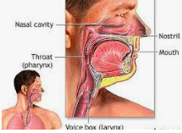
Question: Where is this equation from? What is this process called?

Parts of the Respiratory System
- Nose & Mouth – air comes in through nose & mouth
- Cilia and Mucus
  - air entering the respiratory system must be , , and
  - large dust particles get trapped by the hairs lining the entrance to the nasal cavity
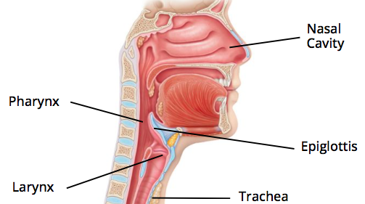
  - cilia sweep the trapped particles and mucus away from the towards the

- Pharynx – acts as a passage for both food and air
  - covers the entrance to the trachea when you swallow flap of tissue
  - air moves from pharynx into the trachea
- Larynx – at the top of the trachea, contains two highly elastic folds of tissue called the
muscles pull the together
air moving between them causes the to vibrate
produces sound allowing you to speak

- Trachea – from larynx air passes through trachea before dividing into the
- Bronchus (bronchi) – from the trachea, each leading to a lung
IN THE LUNG
- Bronchioles – subdivided that continue to divide until reaching
- Alveoli – air sacs that allow between inhaled air and the blood
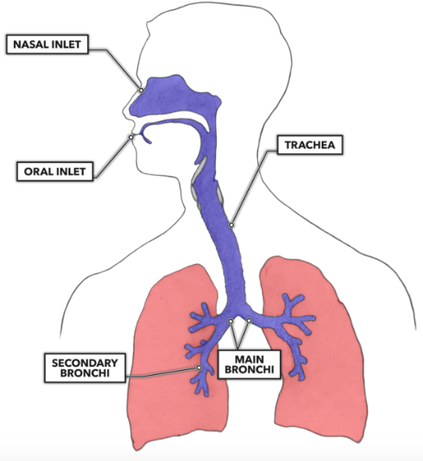
  - surrounded by a network of capillaries
  - grouped little clusters like grapes
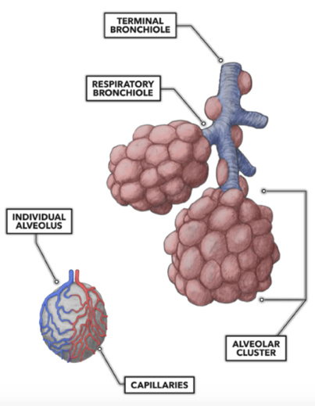

Life is a Highway . . . So is your Respiratory System
- main highway = trachea
- two-lane road = bronchus
- street = bronchioles
- driveway = alveoli

Inhale & Exhale
- When you
you breathe in
blood picks up oxygen from the
- When you
you breathe out , waste, heat
alveoli pick up carbon dioxide from the

Extension: What would happen if you did not have alveoli?

The Pathway of Air . . .
- Air enters the body through the nose or mouth (inhale)
- Air moves through the pharynx and into the .
- Trachea divides into two (connect to the lungs)
- INSIDE the lungs, branch into bronchioles
- At end of the smallest are alveoli
- Each is surrounded by capillaries

