Measuring Homeostasis Activity

BACKGROUND: Homeostasis is the process by which an organism maintains its internal environment. All organisms, from bacteria, to plants, to humans, maintain homeostasis constantly. For examples, in both 25 Degree weather and 95 Degree weather, your body will remain close to 98 Degrees. Your body also regulates the amount of glucose in your blood, the pH of your blood, the amount of salts and fluids in your tissues, the amount of oxygen in your blood, and much more. If an organism goes too far outside of normal conditions, it will become damaged, or even die.
Let’s dig a little deeper, using temperature as an example. Homeostatic control occurs in several steps, involving: A stimulus, receptors, a control center, an effector, and the response. Refer to the diagram at the bottom of the page for a visual.
STIMULUS: Your body begins to overheat. This is the stimulus, or change, that kicks off the homeostatic control system.
RECEPTORS: Next, nerve endings in your skin, and hypothalamus sense that your body is warmer than normal.
CONTROL CENTER: The hypothalamus sends signals to your sweat glands, telling them to produce sweat
EFFECTOR: Your sweat glands release body fluid, causing you to sweat through the pores of your skin.
RESPONSE: The sweat cools your body down, returning it to a normal temperature.
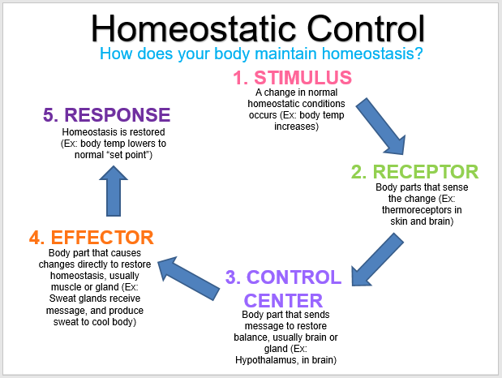
PROCEDURE: Find a partner. Once you have found a partner we will divide the class into 2 groups. Don’t worry, each group will have the opportunity to do both stations, we will switch during the class. Between you and your partner decide who will do the activities for each station. Plan to switch, so whoever does station 1 activities will be able to record for station 2.
Station 1: Temperature Activities | Station 2: Heart Rate Activities
- Sprints & Jumping Jacks | 1. Push-Ups & Burpees
- Submerge Wrists in Ice Water | 2. Deep Breathing

Station 1

- Get your temperature taken record this value in the table below under “Before Activity”
- its time to get your temperature up!
  - sprint 2 lengths of the hallway
  - do 10 jumping jacks
- get your temperature taken record this value in the table below under “During Activity”
- let’s get your temperature up some more!
  - sprint 4 lengths of the hallway
  - do 20 jumping jacks
- get your temperature taken record this value in the table below under “After Activity”
- its cool down time
  - submerge both of your wrists in the bucket of ice water for 60 seconds
  - if its too cold or your hands start to look an odd colour, remove your hands
- get your temperature taken record this value in the table below under “After Cool Down”
- note any additional observations in the table.
Station 2
NOTE: Find your partners heart rate (HR) using the stethoscopes. Once you have found it, count the beats you hear in 1 minute. This will give you the beats per minute which is the value you will record in the table below.

- With your partner, use the stethoscope to find your heart rate (HR) in beats per minute record this value in the table below under “Before Activity”
- It’s time to get your HR up!
  - Do 10 push-ups
  - Do 10 burpees
- Find your heart rate (HR) again record this value in the table below under “During Activity”
- Let’s get your HR up some more!
  - Do 10 more push-ups
  - Do 10 more burpees
- Find your heart rate (HR) again record this value in the table below under “After Activity”
- It’s relaxation time!
  - take some deep breathes and/or walk around the room to calm down
  - have some water or take a seat if needed
- Find your heart rate (HR) for the last time record this value in the table below under “After Cool Down”
- Note any additional observations in the table.

Name: _________________________________ Date:

DATA COLLECTION & OBSERVATIONS:
 | Before Activity | During Activity | After Activity | After Cool Down
Thermoregulation
Observations:

Heart Rate Regulation
Observations:

QUESTIONS:
- What process does your body use to bring your body temperature and/or heart rate back to its steady state?

- Identify each component of the homeostatic control mechanism for thermoregulation and heart rate based off of what you observed/performed during the activity.

Thermoregulation
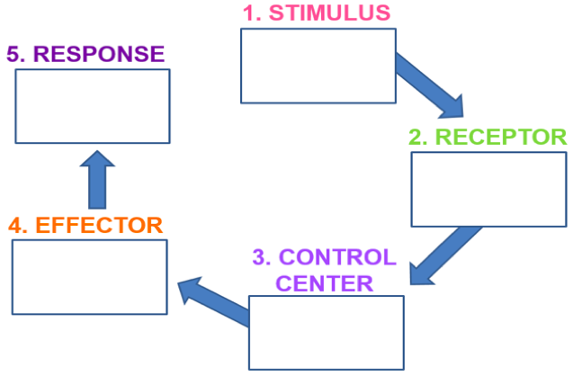

Heart Rate

Extension: What is the scientific name for each receptor? Where are the receptors located? Feel free to use the internet to help you find this information.

- What similarities and differences are there in homeostatic mechanisms between thermoregulation and heart rate?
 | Thermoregulation | Heart Rate Regulation
Similarities
Differences

- If homeostasis did not occur for thermoregulation or heart rate regulation, what is one consequence for each that could occur as a result.

When you are done, hand in the DATA COLLECTION & QUESTIONS portion of this activity as a check in

