Outcome Practice: Respiratory System & Breathing
(Outcomes 22)
Name: Date:

Complete the activity “Build a Lung” found within the classroom and answer the questions below using the video from the top of the page, the activity as well as page 959 in the textbook.

- State what the following materials in the activity were used to represent in the real respiratory system.

straws | Trachea and bronchi and bronchioles
balloons | Lungs
pop bottle | Chest cavity
saran wrap | diaphragm

- Explain how respiration (inhalation and exhalation) work in the body making sure to refer to Boyle’s Law looking at expansion/reduction of chest cavity and pressure changes within causing movement of air.

 | Description of Process
Exhalation | Once the CO2 is released, the diaphragm relaxes causing the chest cavity to increase and in turn decreases the pressure inside compared to the atmosphere. This causes the O2 in the atmosphere to move from a high concentration to a low concentration and enter the body.
Inhalation | When the medulla oblongata recognizes high levels of CO2 in the body it triggers a message to the diaphragm to push up and the volume to decrease in the cavity which in turn increases the pressure within the cavity compared to the atmosphere. This causes the CO2 to go from a high pressure to a low pressure and exit the body.

Inhalation Exhalation
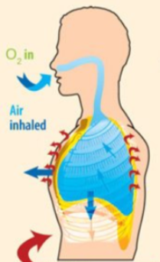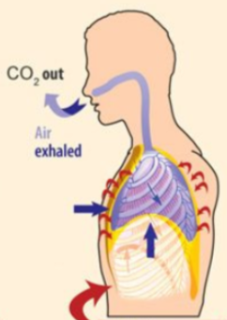
Use your knowledge of inhalation and exhalation to answer the following questions.

1. When you inhale
a) the ribs move _____outward______. inward OR outward
b) the diaphragm moves _______downward_______ upward OR downward
c) there is now _____more_______ space in the chest area. more OR less
d) air rushes _____IN____ to fill this space. in OR out

2. When you exhale
a) the ribs move ________inward________. inward OR outward
b) the diaphragm moves ______upward_______. upward OR downward
c) there is now ______less______ space in the chest area. more OR less
d) because of this pressure, air moves ______out of_______ the lungs. into OR out of

Each of the following goes with either inhaling or exhaling. Place a checkmark in the box where you think each statement belongs.
 | Inhaling | Exhaling
Air moves out of the lungs |  | √
Air moves into the lungs | √
Ribs move out | √
Ribs move in |  | √
Chest space becomes smaller |  | √
Chest space becomes larger | √
Diaphragm moves down | √
Diaphragm moves up |  | √

Fill in the following blanks with the option provided.
- Air that enters the alveoli is rich in oxygen (oxygen OR carbon dioxide)
- Air that leaves the alveoli is rich in carbon dioxide (oxygen OR carbon dioxide)
- Alveoli are surrounded by _______capillaries_________ (capillaries, veins, arteries)
- The capillaries around the alveoli take in oxygen (oxygen OR carbon dioxide)
- The capillaries deliver the waste of carbon dioxide to the alveoli (oxygen OR carbon dioxide)

Match each term with the description.
- exhaling where gases are exchanged 3
- inhaling airs passage to the lungs 4
- alveoli breathing in 2
- trachea surround the air sacs 5
- capillaries breathing out 1

