Outcome Practice: Homeostasis
(Outcome 20)
Name: _____KEY_______ Biology 11

Using your lesson notes, textbook p.895-896 and the Mr. Anderson video on the Weebly to complete the following OP.

When the organ systems of the body work together to maintain a controlled, stable internal environment.
Must occur to keep the body’s system’s functioning and the individual able to live and get back to their state of balance

Use the link https://byjus.com/biology/homeostasis/ (also found on the classroom Weebly) or your other notes on homeostasis to answer question 2 below.
- Identify what occurs at each step of a self-regulating system (stimulus, receptor, control center, effector) that is used to regulate homeostasis within the body.
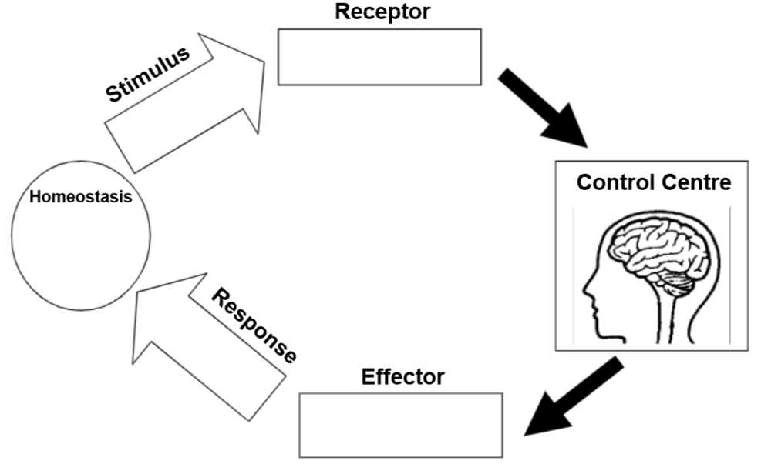
Produces change in variable
“normal” or balanced state
Increases or decreases stimulus
Responds to the commands of control centre with a response
Integration centre, receives & processes information
Sensing Component, responsible for monitoring

