OP – Parts of the Digestive System
(Outcome 24 & 25)
Name: Date:

Label all parts of the digestive system on the diagram below. Include a brief description of their purpose in digestion. Use pages 978-984 in your textbook and your notes to assist you.

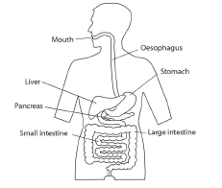

Match the function to the correct digestive organ.
