Pre-Lab Work: Heart Dissection
Name: __________________________ Biology 11
Directions: Read the lab scrip provided first and then answer the questions below prior to the lab day to ensure you complete the lab successfully.
Safety First! These questions are not included with the pre-lab questions on the lab report!
Note: reading through the lab script will assist you; however some further research may be needed.
- What is formalin?

- What is a preserved specimen?

- What is the proper disposal of a preserved specimen?

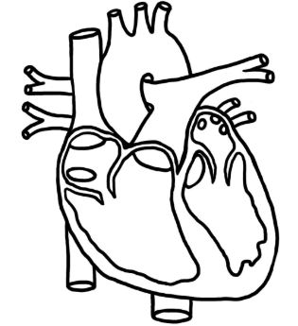
- What is the proper way of cleaning up the lab material (dissection tray & tools)

- Where is the first aid kit in the classroom?
Pre-Lab Questions:
- Using the diagram of the heart, identify the left and right atrium, left and right ventricle, as well as the base and apex of the heart.
Left ventricle
Right atrium
Left atrium
apex
base
Right ventricle

- What are/is the purpose of the following parts of the heart? What do each look like and where are they located?
- Septum

- Chordae tendinae

- What is adipose tissue?

- How are you able to identify the left and right sides of the heart?

- Why do we use a sheep hart to dissect if we want to better understand human physiology?

