Notes: Darwin’s Theory of Evolution
Biology 12 Outcome 16 Name:_________________
Evolution is the change in the _____________ characteristics of populations over successive generations. These characteristics are the expressions of ________ that are passed on from parent to offspring during ____________.

Evolution
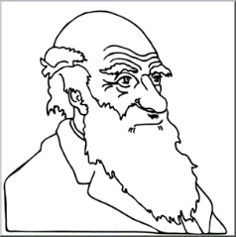
Darwin: developed his theory of evolution through ____________________ selection through understanding the following:
Artificial Selection (Selective Breeding)  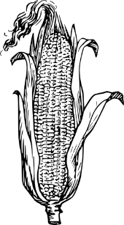  the process where ____________ identify _____________ traits in animals and plants and use these traits to develop desirable phenotypic traits by breeding. It is an artificial or human-made process that is a ______________ process. | 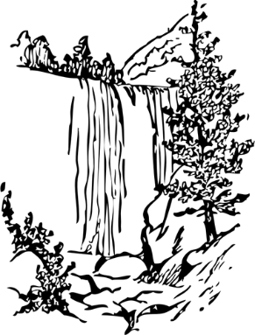  Natural Selection  takes place in ____________ populations within natural ___________________. This is how ______________ thought organisms evolved and believed it was a __________ process.
Based on 3 Concepts:
- Struggle for Existence
- Increase in _____________ rates makes ___________________ as there will be _______________ food, living space and ______________________ to live available.
- Survival of the Fittest
- The ability for an organism to ___________________ and ___________________ in an environment is called its ______________________.
- Thought fitness was a result of ____________________ which are inherited characteristics that increase an organism’s _______________________ of survival.
- Decent with Modification
- Over long periods of time _____________ selection produced organisms that have different structures and have different niches and ___________.
- Believed all organisms are related to each other through “_________________”.. last universal common ancestor.

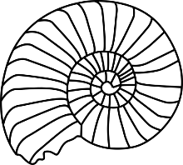

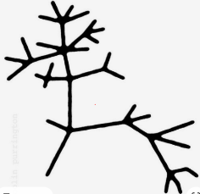

Summary of Darwin’s Theory of Evolution:

V Organisms show ______________, which is heritable.
O Organisms produce more ____________________ than will _________________.
C Therefore, there is __________________ for limited ___________________.
A Organisms with __________________________ best suited to their ___________________ will out-___________________ others.
R These organisms will have more successful ____________________ and passing on of their ____________________ traits to their ______________ while others _______________ or leave ____________________ offspring.

*The process of natural selection causes species to change over time. *

