Outcome Practice: Respiratory System & Breathing
(Outcomes 22)
Name: Date:

Complete the activity “Build a Lung” found within the classroom and answer the questions below using the video from the top of the page, the activity as well as page 959 in the textbook.

- State what the following materials in the activity were used to represent in the real respiratory system.

straws

balloons

pop bottle

saran wrap

- Explain how respiration (inhalation and exhalation) work in the body making sure to refer to Boyle’s Law looking at expansion/reduction of chest cavity and pressure changes within causing movement of air.

Description of Process
Exhalation

Inhalation

Inhalation Exhalation
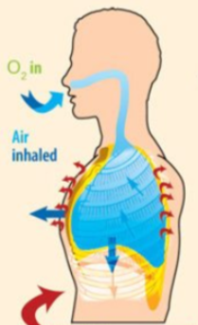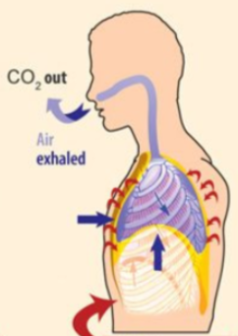

Use your knowledge of inhalation and exhalation to answer the following questions.

1. When you inhale
a) the ribs move _______________________. inward OR outward
b) the diaphragm moves _______________________ upward OR downward
c) there is now __________________ space in the chest area. more OR less
d) air rushes _____________ to fill this space. in OR out

2. When you exhale
a) the ribs move _________________________. inward OR outward
b) the diaphragm moves _____________________. upward OR downward
c) there is now _________________ space in the chest area. more OR less
d) because of this pressure, air moves _____________________ the lungs. into OR out of

Each of the following goes with either inhaling or exhaling. Place a checkmark in the box where you think each statement belongs.
 | Inhaling | Exhaling
Air moves out of the lungs
Air moves into the lungs
Ribs move out
Ribs move in
Chest space becomes smaller
Chest space becomes larger
Diaphragm moves down
Diaphragm moves up

Fill in the following blanks with the option provided.
- Air that enters the alveoli is rich in (oxygen OR carbon dioxide)
- Air that leaves the alveoli is rich in (oxygen OR carbon dioxide)
- Alveoli are surrounded by (capillaries, veins, arteries)
- The capillaries around the alveoli take in (oxygen OR carbon dioxide)
- The capillaries deliver the waste of to the alveoli (oxygen OR carbon dioxide)

Match each term with the description.
- exhaling where gases are exchanged
- inhaling airs passage to the lungs
- alveoli breathing in
- trachea surround the air sacs
- capillaries breathing out

