Cell Components Diagram
Outcome 5
Name: ________________________________ Biology 11
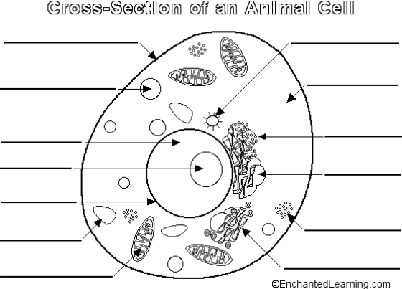
Directions: Label the essential structures (bolded) of the plant and animal cells found below, make sure to highlight each of the essentials. Use the textbook on page 174-181 to assist you. Check your answers using the key on the back board and make any necessary corrections. Continue with the extension structures when done.
Vocabulary:
Cell Membrane
Nucleus
Chromosomes
Ribosomes
Mitochondria
Cytoplasm
Centrioles
Vacuole
Rough Endoplasmic reticulum
Lysome
Smooth Endoplasmic reticulum
Golgi Apparatus
Nucleolus
Nuclear Membrane

Vocabulary:
Cell Wall
Cell Membrane
Nucleus
Chromosomes
Ribosomes
Mitochondria
Cytoplasm
Chloroplast
Vacuole
Nucleolus
Rough Endoplasmic Reticulum
Chloroplast
Smooth Endoplasmic Reticulum
Golgi Apparatus
Nuclear Membrane

