Outcome Practice: Evolution of Kingdom Animalia
(Outcome 17)

Name: Biology 11

- What are the key characteristics that define an organism as being a part of Kingdom Animalia?

- The cladogram below shows the evolutionary path kingdom animalia. Each of the derived characteristics are represented by a dot. Label each derived characteristic (evolutionary change) that occurred at each phylum using the list of derived characteristics found in the first column of the chart. Give a brief explanation of what each means in the 2nd column of the chart. You can use the Bozeman Science video by Mr. Anderson as well as textbook pages 660 – 662 to help you, both are found on the online classroom.

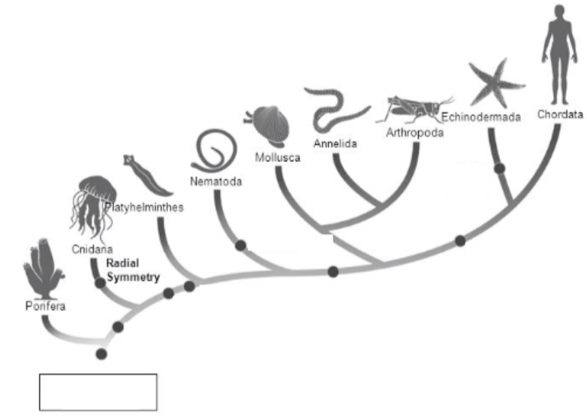

Derived Characteristics | Description of Characteristic
Tissues

Radial Symmetry

3 Germ Layers;
Bilateral Symmetry

Protostome Development

Pseudocoelom

Coelom

Deuterostome Development

- What are the 4 criteria that define a animal as complex vs. simple? Explain what each criteria means. Use textbook page 660 to help you.

Criteria for simple vs. complex | Explanation of Criteria

- Give 3 examples of complex animals and 3 examples of simple animals. Justify why you think each animal falls under that category.

Examples of Simple organisms | Justification
Examples of Complex organisms | Justification

