Outcome Practice: Homeostasis Feedback Loops
(Outcome 21)
Biology 12 Name: ____________________________

- Explain what a feedback loop is and what the purpose of them are.

- There are 2 types of feedback loops, positive and negative, give a brief explanation of how each works.

- Using textbook page 1001 create a feedback loop that works to maintain homeostasis when you become thirsty (have lowered levels of water in the body).

- Feedback loop controlling the blood sugar levels in the body are controlled by insulin and glucagon.
- What is insulin and glucagon?

- What is the normal level of glucose in the blood?

- Create a diagram showing the negative feedback loop for rising glucose levels in the blood. You may require externa resources to assist you with this.

- Explain where the feedback loop is broken down when a person is a diabetic. Use page 1007 in the textbook to help you.

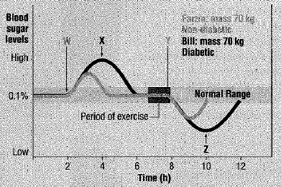
- Use the graph below showing two individuals’ glucose levels and answer the questions below.

- Which hormone injection did Bill receive at the time labelled X? Provide your reasons.
- What might have happened to Bill’s blood sugar level if hormone X had not been injected? Provide your reasons.
- Explain what happened at time W for Bill and Farzin?
- Explain why blood sugar levels begin to fall after time Y?
- What hormone might Bill have received at time Z? Explain your answer.
- Why is it important to note that both Farzin and Bill had the same body mass?
- What differences in blood sugar levels are illustrated by the data collected from Bill and Farzin
- Why do Bill and Farzin respond differently to varying levels of blood sugar?

- a) What is cortisol? Which organ or gland produces it?
b) What is the purpose of this hormone in the body?
c) What negative effects does this hormone have on the human body?
d) Create a negative feedback loop showing how cortisol works in the body. You may require external research to do this.

