Outcome Practice: Identifying Plants
(Outcomes 15 & 18)
Biology 11 Name: ______________________

- Use the notes as well as the outcome practice on the evolution of plants to assist you in identifying which group within Kingdom Plantae each specimen below is from.

Specimen | Group Identification  (bryophyte, pterophyte, conifrophyta or anthrophyta) | Justification of answer  (explain why you placed the specimen in that group)
Example:  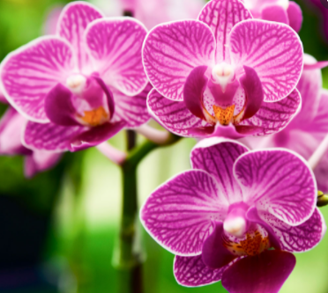  Orchid | anthrophyta | - Flowering  - Pollen & ovum  - Protected seed
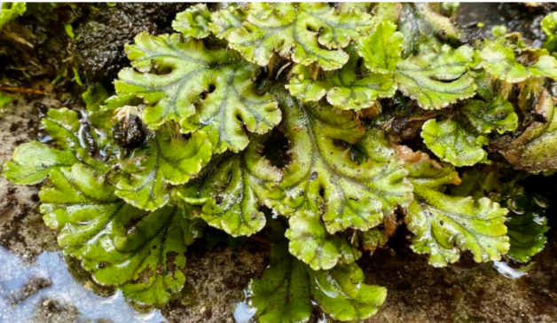
Liverwart
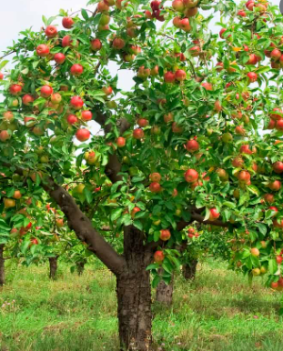
Apple Tree
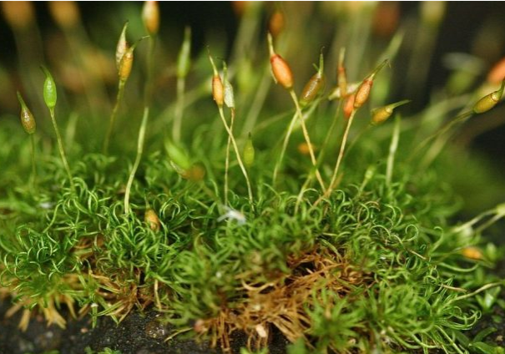
Moss
Evergreen Trees
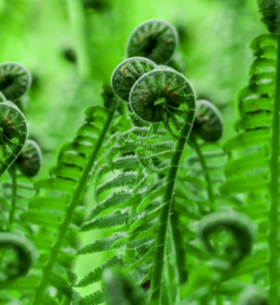
Fiddleheads

- Create a dichotomous key for the classification of the plant groups we have been discussing (bryophytes, pterophytes, coniferophytes, and anthophytes). Remember that a dichotomous key answers yes or no questions until it gets to one of the classifications.

