Outcome Practice: Lamarck’s Theory of Evolution
(Outcome 14)
Name: Biology 11
Directions: Complete the questions below by using the video attached to the lesson as well as your textbook on page 376.
- Generally speaking, what did Lamarck believe caused organisms to “evolve” and change their traits and pass these off to their young?

- Using the following characteristics found in nature, explain how Lamarck would describe how these characteristics came to be and how he believed the animals “evolved” or inherited traits.
Trait of organism | How Lamarck believed it occurred | How is this passed onto young?
Long necks in a giraffe.
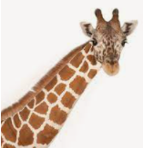

Large claws in male fiddler crabs.
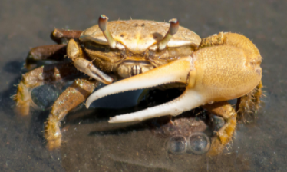

- Explain how Darwin’s overall theory was different from Lamarck’s.

