Outcome Practice: Neural Circuits
(Outcome 19)
Biology 12 Name: ______________________
- Give at least 3 examples of stimuli and their corresponding receptors.

- Which of the below shows the order of structures involved in a neural circuit?
  - Effector motor neuron interneuron sensory neuron receptor
  - Effector sensory neuron motor neuron interneuron receptor
  - Receptor sensory neuron interneuron motor neuron effector
  - Receptor motor neuron sensory neuron interneuron effector

- Using the diagram below, label each of the key parts of a neural circuit:
sensory neuron | spinal cord (CNS) | message to brain | dendrite
receptor | interneuron | synapse | axon terminal
motor neuron | stimulus | effector
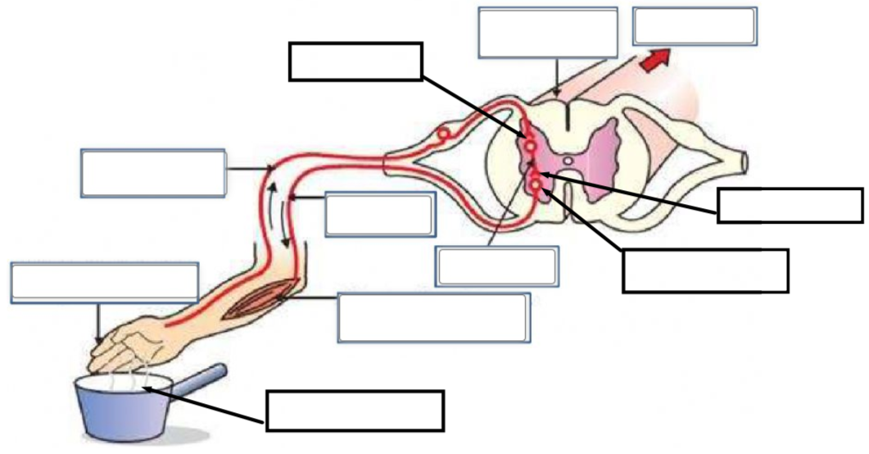

- Explain why reflex arcs are an automatic behaviour?

- Create a neural circuit diagram showing a person’s finger being pricked by a needle. Make sure to create a diagram that includes the receptor, 1 sensory neuron, 2 interneurons and 3 motor neurons and the response. Label the types of neurons, where the synapses are, a dendrite, a cell body, an axon, and an axon terminal as well as the direction of the impulse.

