OP – Parts & Purpose of the Respiratory System
(Outcome 22)
Name: Date:

What is respiration?
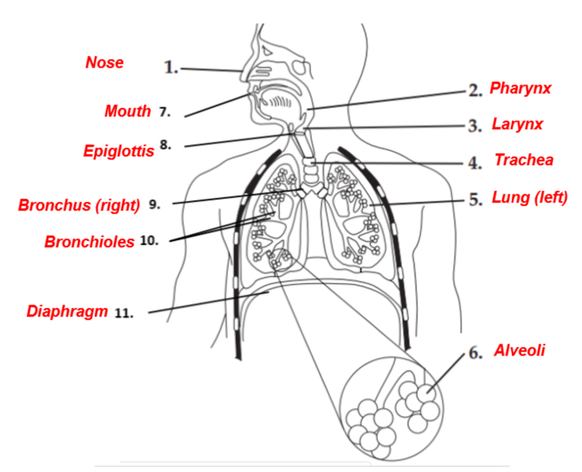

What is the purpose of the respiratory system?

Diagram: Parts of the Respiratory System
Label the parts of the respiratory system using the word
bank provided as well as your textbook pg. 956-958.

Word bank of structures:

Bronchioles
Mouth
Larynx
Diaphragm
Alveoli
Nose
Trachea
Pharynx
Epiglottis
Lung (left)
Bronchus (right)

Rewrite the parts of the respiratory system listed above in the order in which air goes through the body. Exclude the term diaphragm.

OP – Respiratory System Disorders
(Outcome 27)

Use page 1044 in your textbook and the internet, complete the following chart.

 | Define | Causes  (Is it genetic?) | Symptoms | Treatment | EXTENSION:  Impact on Homeostasis
Asthma
Pneumonia
Bronchitis

Emphysema

Using pages 961-963 in your textbook and the internet explain the effect of tobacco and smoking use on the body.

Tobacco

Smoking

