Outcome Practice: Pedigree Charts
Name: _____________________ Biology 12
Directions: Answer the questions below using your notes and knowledge of genetics. The key below will assist you in understanding pedigree chart information.
Pedigree Chart Key:

- The following pedigree chart looks at horses and the trait that deals with fast or slow-twitch muscle response. Slow-twitch muscle is shaded below.
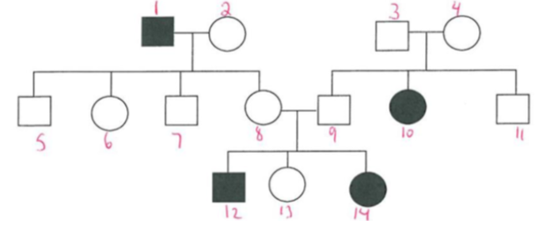
I

II

III
- Explain the family relationship that 12 has with 2.
- State the genotype for each horse in the pedigree chart. If you are uncertain of its genotype, state all that are applicable.
- Can either individual 8 or 9 be homozygous? Why?

- Examine the following pedigree chart for colour blindness in humans, shaded areas represent a colour blinded person.
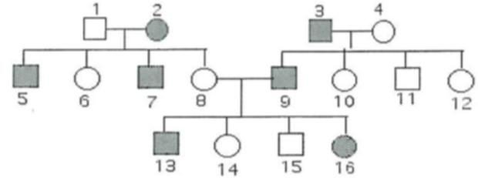
I

II

III

- What is the relationship between 10 and 11?
- Indicate the genotype for each of the individuals found on the pedigree chart. If you are uncertain of its genotype, state all that are applicable.

- As a doctor you are faced with an unknown disease showing in a family. The below pedigree chart maps out the occurrence of this disease with the affected individuals being shaded in.
I

II

III

IV
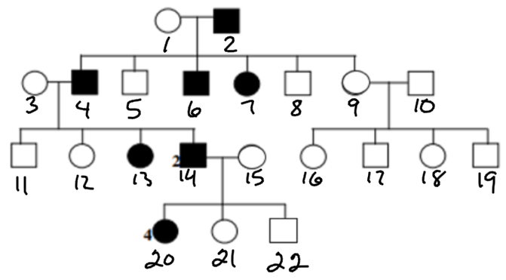

- What is the relationship between 1 and 4?
- Indicate the genotype for each of the individuals found on the pedigree chart. If you are uncertain of its genotype, state all that are applicable.

- The following pedigree chart shows a family that has hemophilia run through it. The individuals shaded have hemophilia.
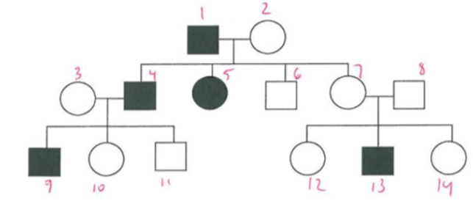
I

II

III

- What is the relationship between 7 and 8?

- Indicate the genotype for each of the individuals found on the pedigree chart. If you are uncertain of its genotype, state all that are applicable.

