Outcome Practice: The Brain
(Outcome 17)
Name: ____________________________________ Biology 12
Directions: Complete the questions below using the textbook on pages 901 to 903 to assist you.
- Using diagram #1 below of the brain, label each part indicated.
- Briefly describe the function for each part labeled on diagram #1. Note: you may need to look elsewhere for the medulla oblongata and midbrain.

- What is the cerebrum divided into and what responsibilities does it have? What connects the two sides of the cerebrum?

- Using diagram #2 showing the lobes of the brain, label each lobe.
- Using the link on classroom notebook “The Lobes of the Brain”, indicate what each lobe is responsible for.

- Indicate what side of the body each hemisphere of the brain controls and indicate what each hemisphere is associated with.

Diagram #1: The Brain
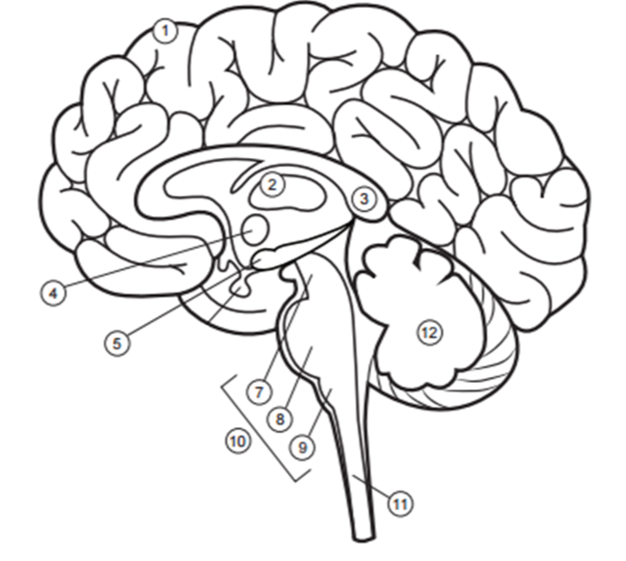
Please Label the following structures of the brain – spinal cord, midbrain, cerebellum, hypothalamus, corpus collosum, cerebrum, thalamus, pituitary gland, pons, medulla oblongata, hippocampus, brain stem

6

Diagram #2: Lobes of the Brain
Label the Following: frontal lobe, parietal lobe, temporal lobe, occipital lobe, cerebellum and brain stem.
