Outcome 2 Practice: Mendel’s Experiments
Name: Biology 12
Directions: Use the tutorial video posted as well as your textbook on pages 263-266 to assist you in completing the following questions.
- What is the difference between cross-pollination and self-pollination?

- Explain what the P-Generation, F₁- Generation and F₂ – Generation are.

- List the 7 characteristics Mendel used to study pea plants and state the two alleles each characteristic could express. Highlight the dominant alleles.

- What is a purebred and why is it important that Mendel used pure-breads as his P-generation during his studies for each trait?

- Explain what occurred with the offspring found in the F₁ generation for any two pure-bread traits (describe the phenotypes produced).

- Explain what occurred with the offspring found in the F₂ generation of any two F₁ plants pollinated (describe the phenotypes produced).

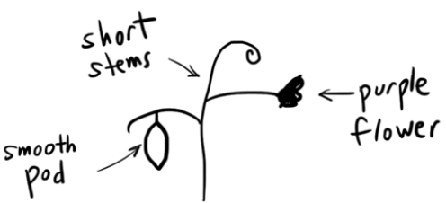
- Using the diagram of an F₁ plant below, indicate what the possible alleles the P-generation could have had, make sure to think about dominant and recessive alleles and remember a parent may have more than one option.

- Draw a picture of the F₁ plant that would be produced from the P-generation described by the traits listed below. Remember you will need to refer to the dominant and recessive traits for Mendel’s experiments.

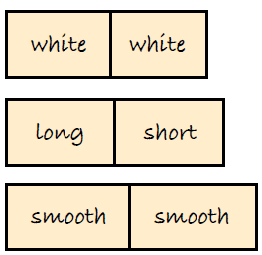
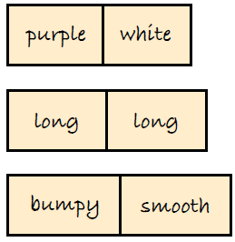
- b)

