Own Notes: Types of Neurons & The Synapse
(Outcome 19)
Name: Biology 12
Directions: Complete the following questions using the textbook on pages 897 and 898 to assist you. These will be considered your notes and will be referred to in the future.
- What are the messages sent through neurons called? What are the messages sent as?

- There are 3 main types of neurons (sensory neurons, motor neurons and interneurons), below is a diagram showing what they look like. Explain what direction each of the types of neurons move impulses along with the help of the textbook on page 897.

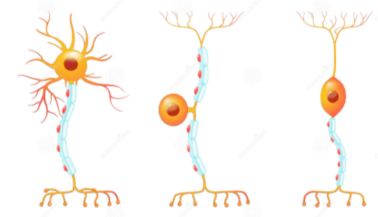

Motor Neuron Sensory Neuron Interneuron

- Which direction do nerve impulses move in (dendrite to axon or axon to dendrite)?

- Using page 900, answer the following questions:
  - Where are synapses located?
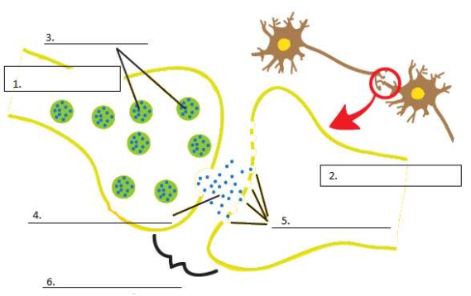
  - What is the purpose of a synapse?
  - What are neurotransmitters?
  - Using the diagram to the right showing a synapse, label the following parts: axon, synaptic cleft, vesicle, dendrite, pre-synaptic cell, neurotransmitter, receptors and post-synaptic cell.

Grade 11 Review:
- What is the purpose of a cell membrane?
- What is the purpose of a protein channel found within a cell membrane?
- What is the difference between passive and active transportation across the membrane?

