Practice - Review of Cell Division
Name: Biology 12
Directions: Answer each of the following questions to help you prepare for the previous knowledge you should have for unit 1 in genetics. You can use the textbook on pages 244-249 as well as pages 275-278 to assist you. I have also added some links to interactive websites and videos that will help you better understand the information as well.
- What is the purpose of mitosis? What type of cells (haploid or diploid) are produced from this division and how many cells are made in the end? How do they compare to the parent cell?

- What occurs during cytokinesis and why is it not considered part of cell division?

- What is the purpose of meiosis? What type of cells (haploid or diploid) are produced from this division and how many cells are made in the end? How do they compare to the parent cell?

- During Prophase 1 of meiosis the chromosomes cross over, explain what the significance of this process is and draw a picture that allows you to understand what occurs during this time.

- Using the diagram below, create drawings for the 2 divisions that occur during meiosis using an organism that would have 4 sets of homologous chromosomes. Create notes for yourself about what is occurring to the chromosomes in each step if the drawing is not enough for you to remember.
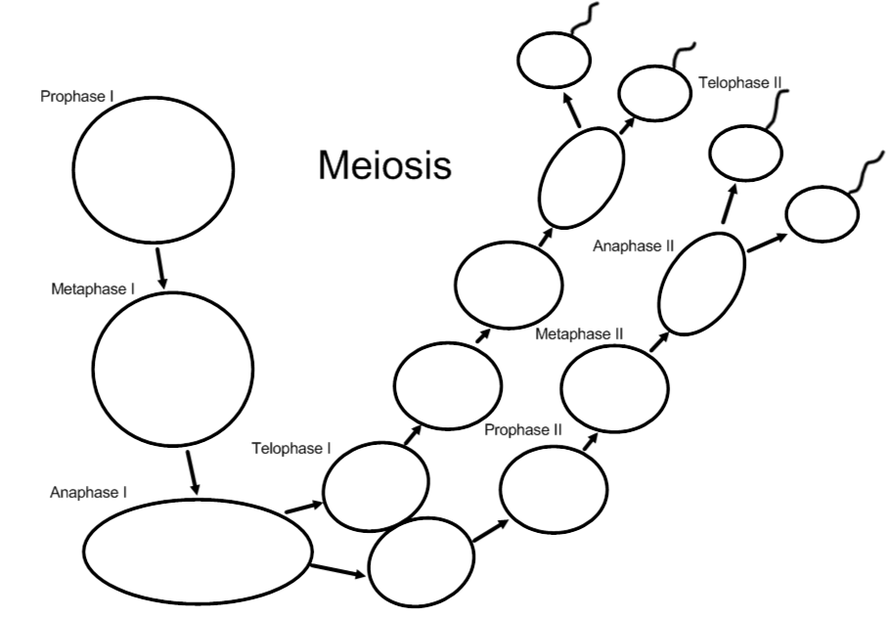

- Explain why cells do not go through interphase again between meiosis I and meiosis II.

- Using page 278 in the textbook, state what the cells produced during meiosis are called in general and what they are called particularly for males and females.

- Using the same page as above, explain what is different about the result of meiosis is for male and female animals.

