Station #4: Types of Circuits
Name: ________________________ Mission B: Electric Circuits Science 9
- Complete the missing parts from the table below by either drawing the symbol or naming the component that is drawn already.
Resistor
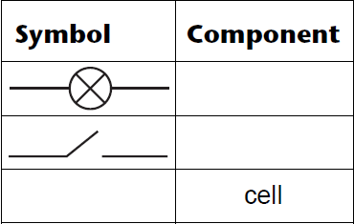

- Draw a circuit diagram indicating the direction of the electric current for each circuit below and state if it is a parallel or series circuit.
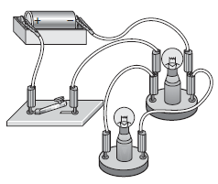
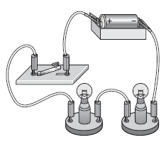
- b) c)
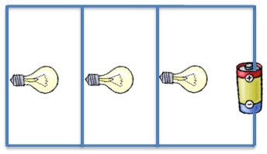

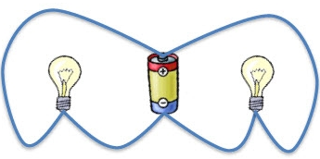
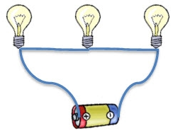
d) e)

- Put a checkmark under each of the schematic diagrams below that would have the light bulb(s) light up. For the ones that you do not put a checkmark for explain why the circuit will not allow for the light bulb to light.
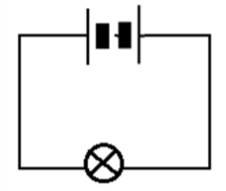
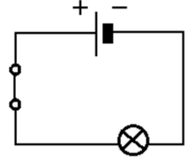
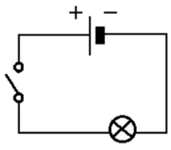
- b) c)

- Complete the sentences below by crossing out the wrong bolded words.

- In a series circuit, as more lamps are added the lamps get brighter / get dimmer / stay the same brightness and the current through each lamp increases / decreases / stays the same.
- In a parallel circuit, as more lamps are added the lamps get brighter / get dimmer / stay the same brightness and the current through each lamp increases / decreases / stays the same.

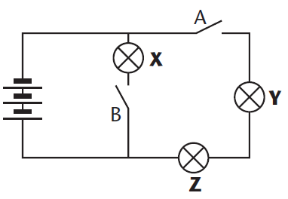
- Look at the circuit in the diagram below. Circle the correct letter(s) indicating which lamp or lamps will light when:

- only switch A is closed? X Y Z
- only switch B is closed? X Y Z
- switches A and B are closed X Y Z

- For a summer party, some friends are putting up a string of lights in the garden. What will happen if a bulb blows:
- If the lights were wired in series?

- if the lights were wired in parallel?

