Reroductive System – Self-Directed Unit
Task #1
Biology 12

Structure & Function
Outcome 22: I can identify, name, and explain the function major organs of the male and female reproductive systems.

Directions: Label and explain the function of the indicated structures for the 3 diagrams below of the male and female reproductive systems using pages 1010 to 1012 in your text and/or pg. 508 to 515 in the Nelson textbook. You can find these on the classroom website.

Diagram: Female Reproductive System & Organs
Label: fallopian tube, ovaries, uterus womb), cervix, vagina
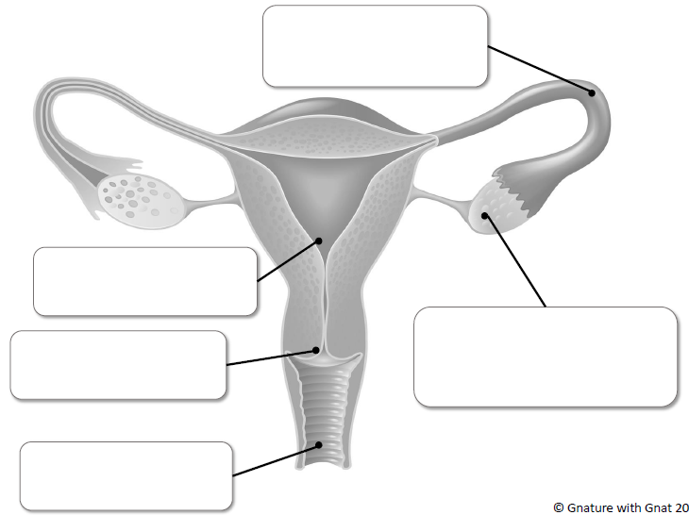
Click or tap here to enter text.
Click or tap here to enter text.
Click or tap here to enter text.
Click or tap here to enter text.
Click or tap here to enter text.

Diagram: Male Sperm
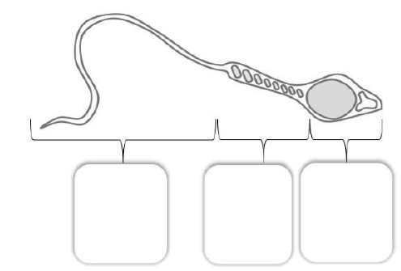
Label: Male Sperm: head, midpiece, tail

Click or tap here to enter text.
Click or tap here to enter text.
Click or tap here to enter text.

Diagram: Male Reproductive System & Organs
Label: prostate gland, urethra, penis, Vas deferens, epididymis, testes
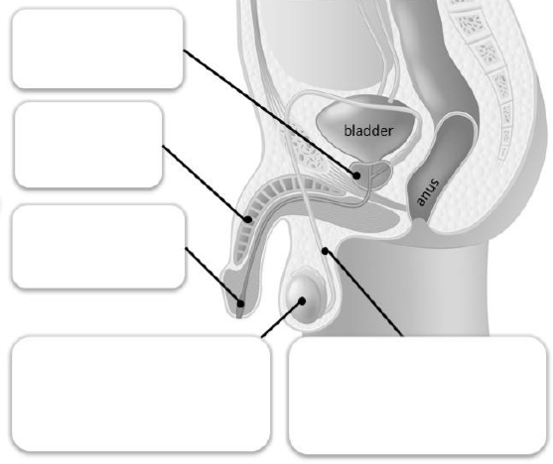
Click or tap here to enter text.

Click or tap here to enter text.

Click or tap here to enter text.

Click or tap here to enter text.
Click or tap here to enter text.

