Reroductive System – Self-Directed Unit
Task #2

Biology 12
Name:
Development of Sperm (Spermatogenesis)
Outcome 23: I can explain the events leading up to and including human conception.
Directions: Complete the following questions using your textbook (Prentice Hall) on pages 1010 to 1012 as well as the Nelson textbook on pages 508 to 515 to assist you. Remember this material will be handed in with your extension portfolio.

- What is the main purpose of the male reproductive system?

- What indicates the completion of puberty for males?

- What is a sperm (be specific) and indicate specifics about its chromosomal make-up?

- Where are sperm produced, what structure?

- Trace the pathway of sperm from seminiferous tubules to the time it leaves the body.

- What is seminal fluid and what contributes to its production? What is its purpose?

- List the hormones that are involved with the male reproductive system, indicate the gland that produces each hormone and what is the job/ role of each hormone is?

Development of Eggs (Oogenesis) & Ovulation

- What is the main purpose of the female reproductive system?

- Describe the pathway of the egg from ovary to outside the body (assume no fertilization occurs).

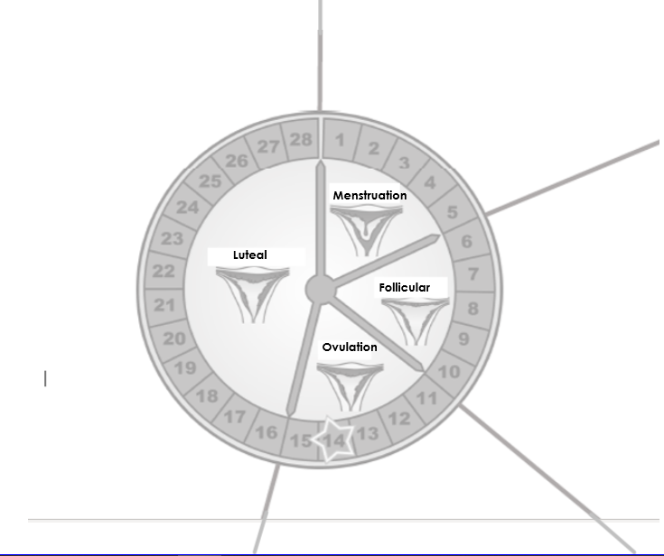
- Using the diagram below showing the phases of a female’s menstrual cycle and when/for how long each phase lasts, indicate what event(s) occur and what hormone(s) are produced during each phase.

- Distinguish between the follicle and the corpus luteum.

- List the hormones involved in the female reproductive system. What does each control? What glands are involved with each?

